Help Avoid the 3 Main Causes of Property Loss at UTHSC-H

The three main causes of property loss at UTHSC-H in FY06 were water leaks, theft, and electrical power interruption. These three perils resulted in over $331,000 in direct loss and untold disruption to teaching, research, and service activities. The deductible for the UTS Comprehensive Property Protection Program is $250,000 per occurrence, in FY06 none of the losses exceeded the per occurrence deductible, however the sum of retained losses exceeded the deductible by $140,000. In special cases additional insurance can be purchased*. Summarized below are simple steps that can be taken to avoid such losses.

 | Potential For Loss | Simple Prevention Measures | For more information and assistance
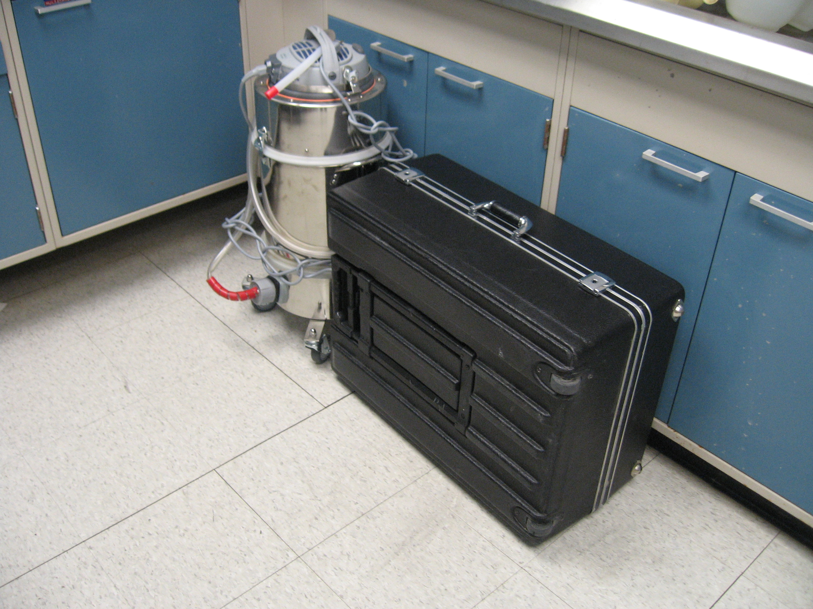 | Water Damage  Water damage accounted for $221,000 of loss in FY06. Water can enter a lab or office from the same floor or from the floor above. | Move equipment off of the floor and cover when not in use. Evaluate possible purchase of supplemental insurance for certain types of equipment* | Contact Facilities Planning and Engineering for more information, (713)500-3498.
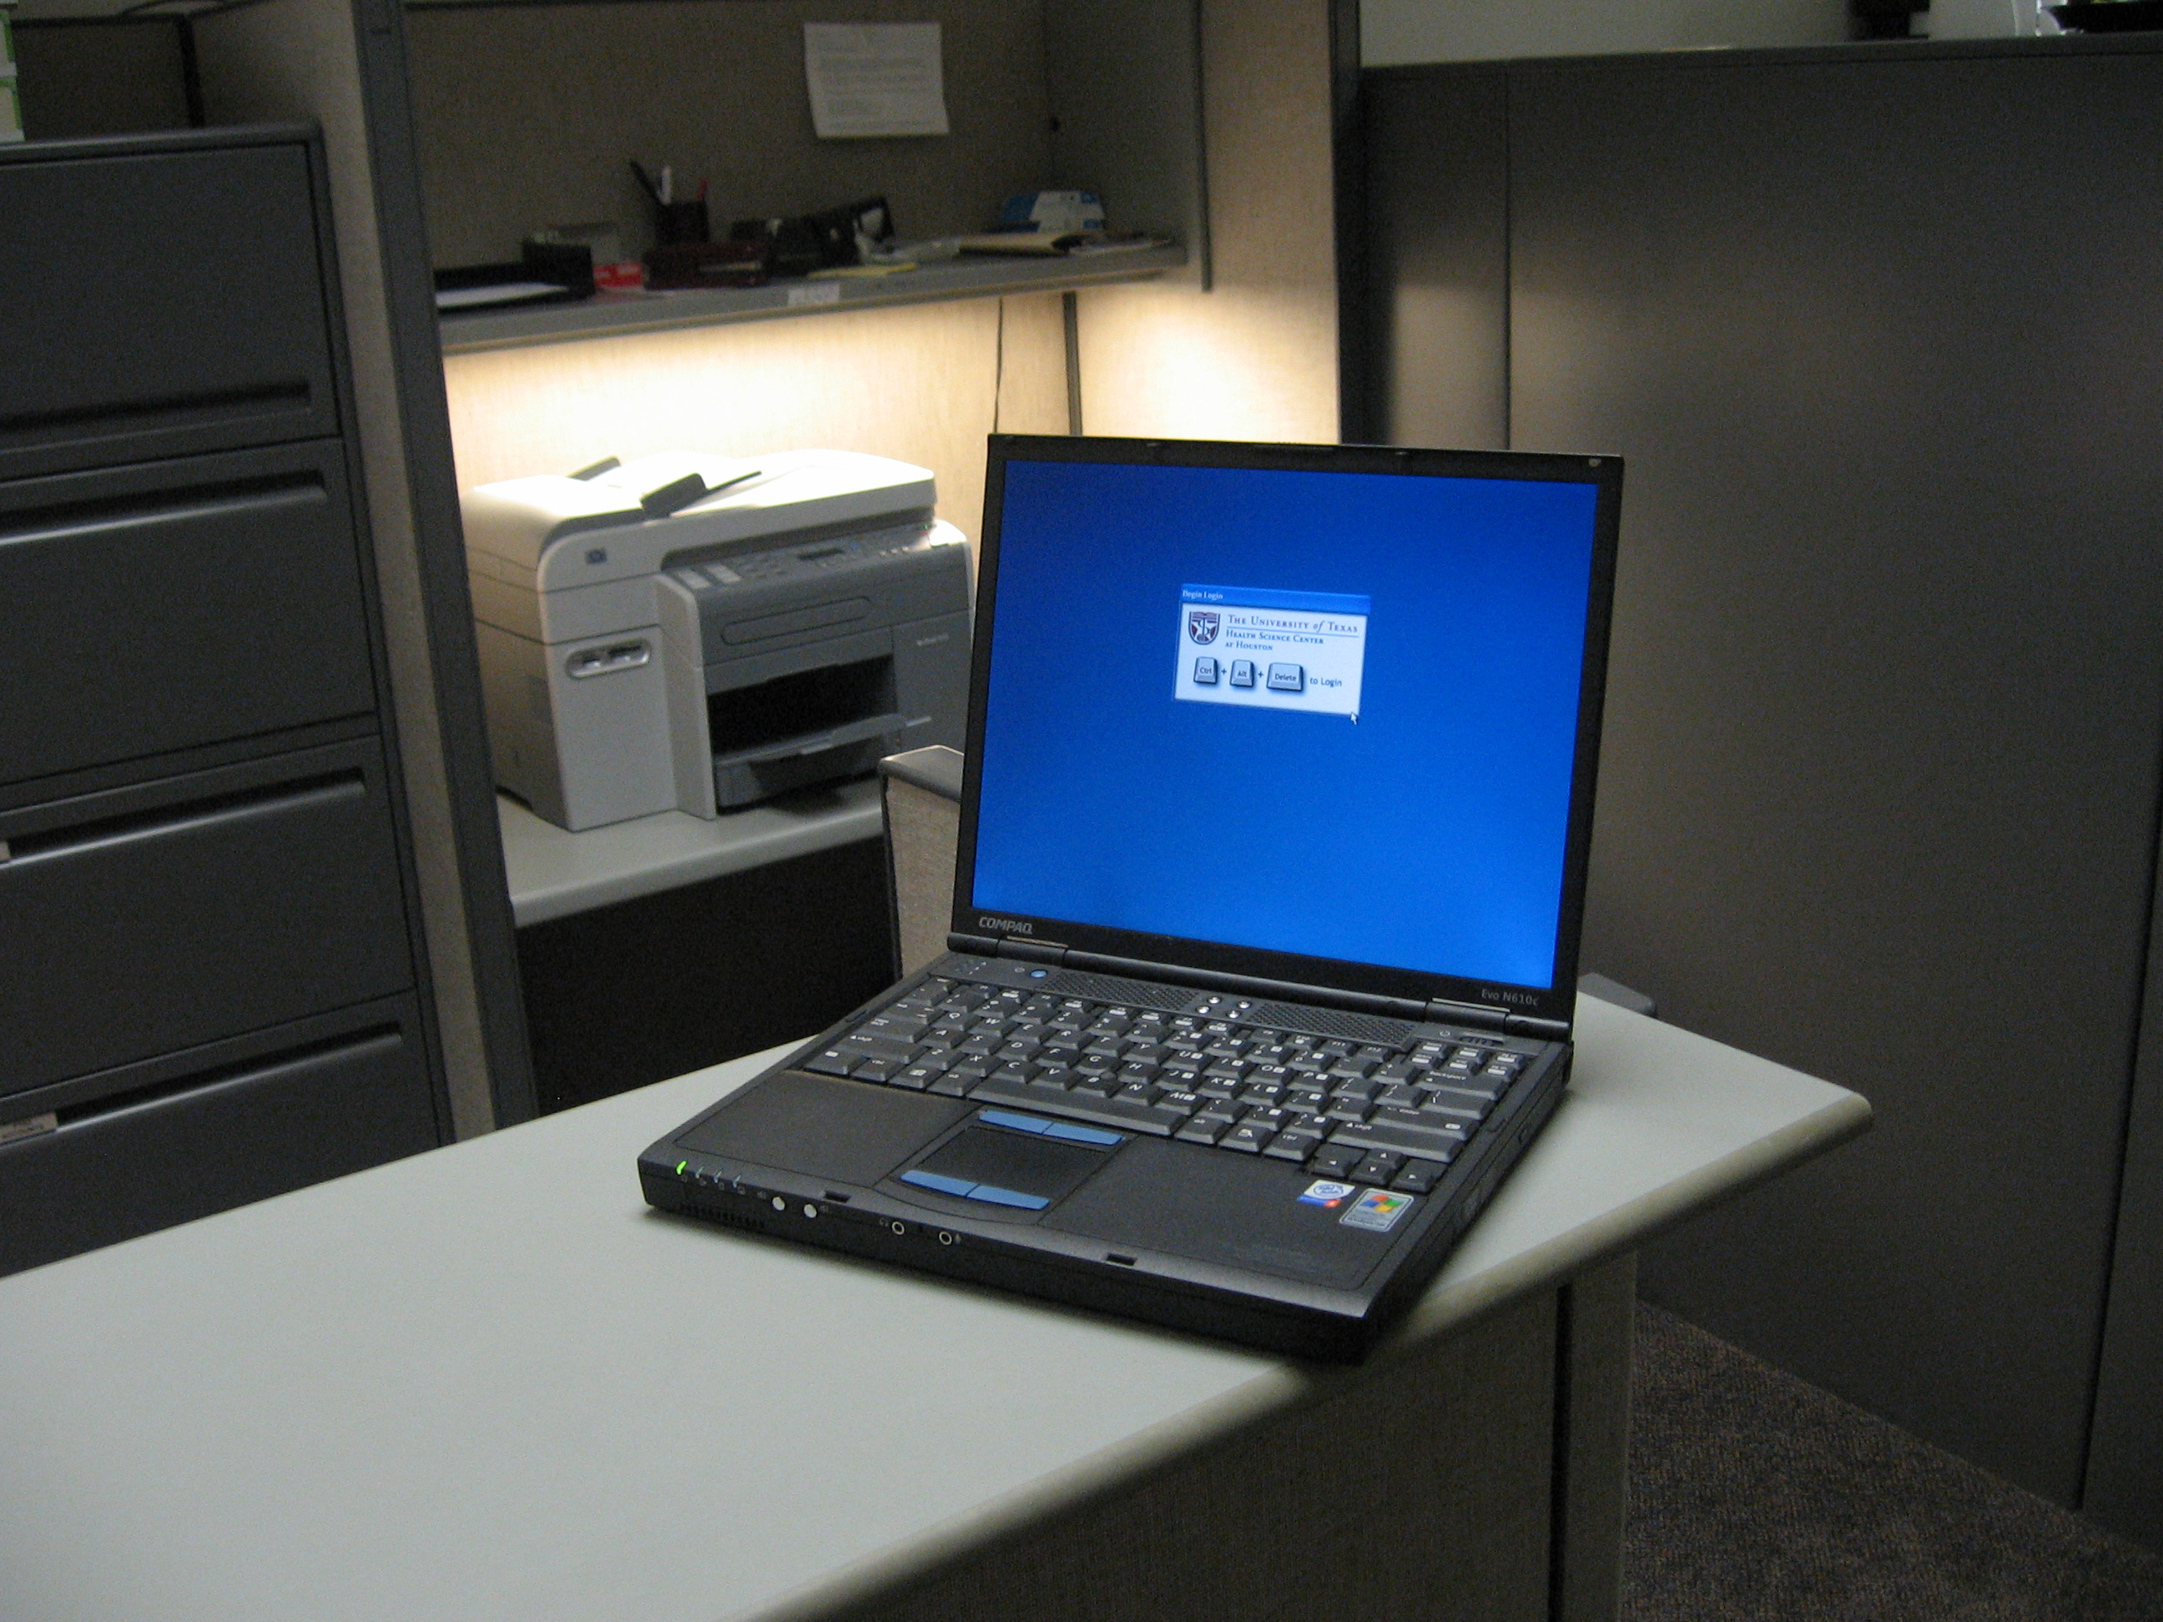 | Theft  Theft accounted for $90,114 of loss in FY06, the majority of which were theft of laptops, PDAs and cell phones. | Secure laptops, PDA’s, or cellular phones. Always backup data and keep it in a physically separate location. For more information about how to lock a PC or laptop: http://www.uth.tmc.edu/med  /msit/howdoi/physical_security.htm  Evaluate possible purchase of supplemental insurance for certain types of equipment* | Contact University of Texas Police Department for more information, (713)794-4357.
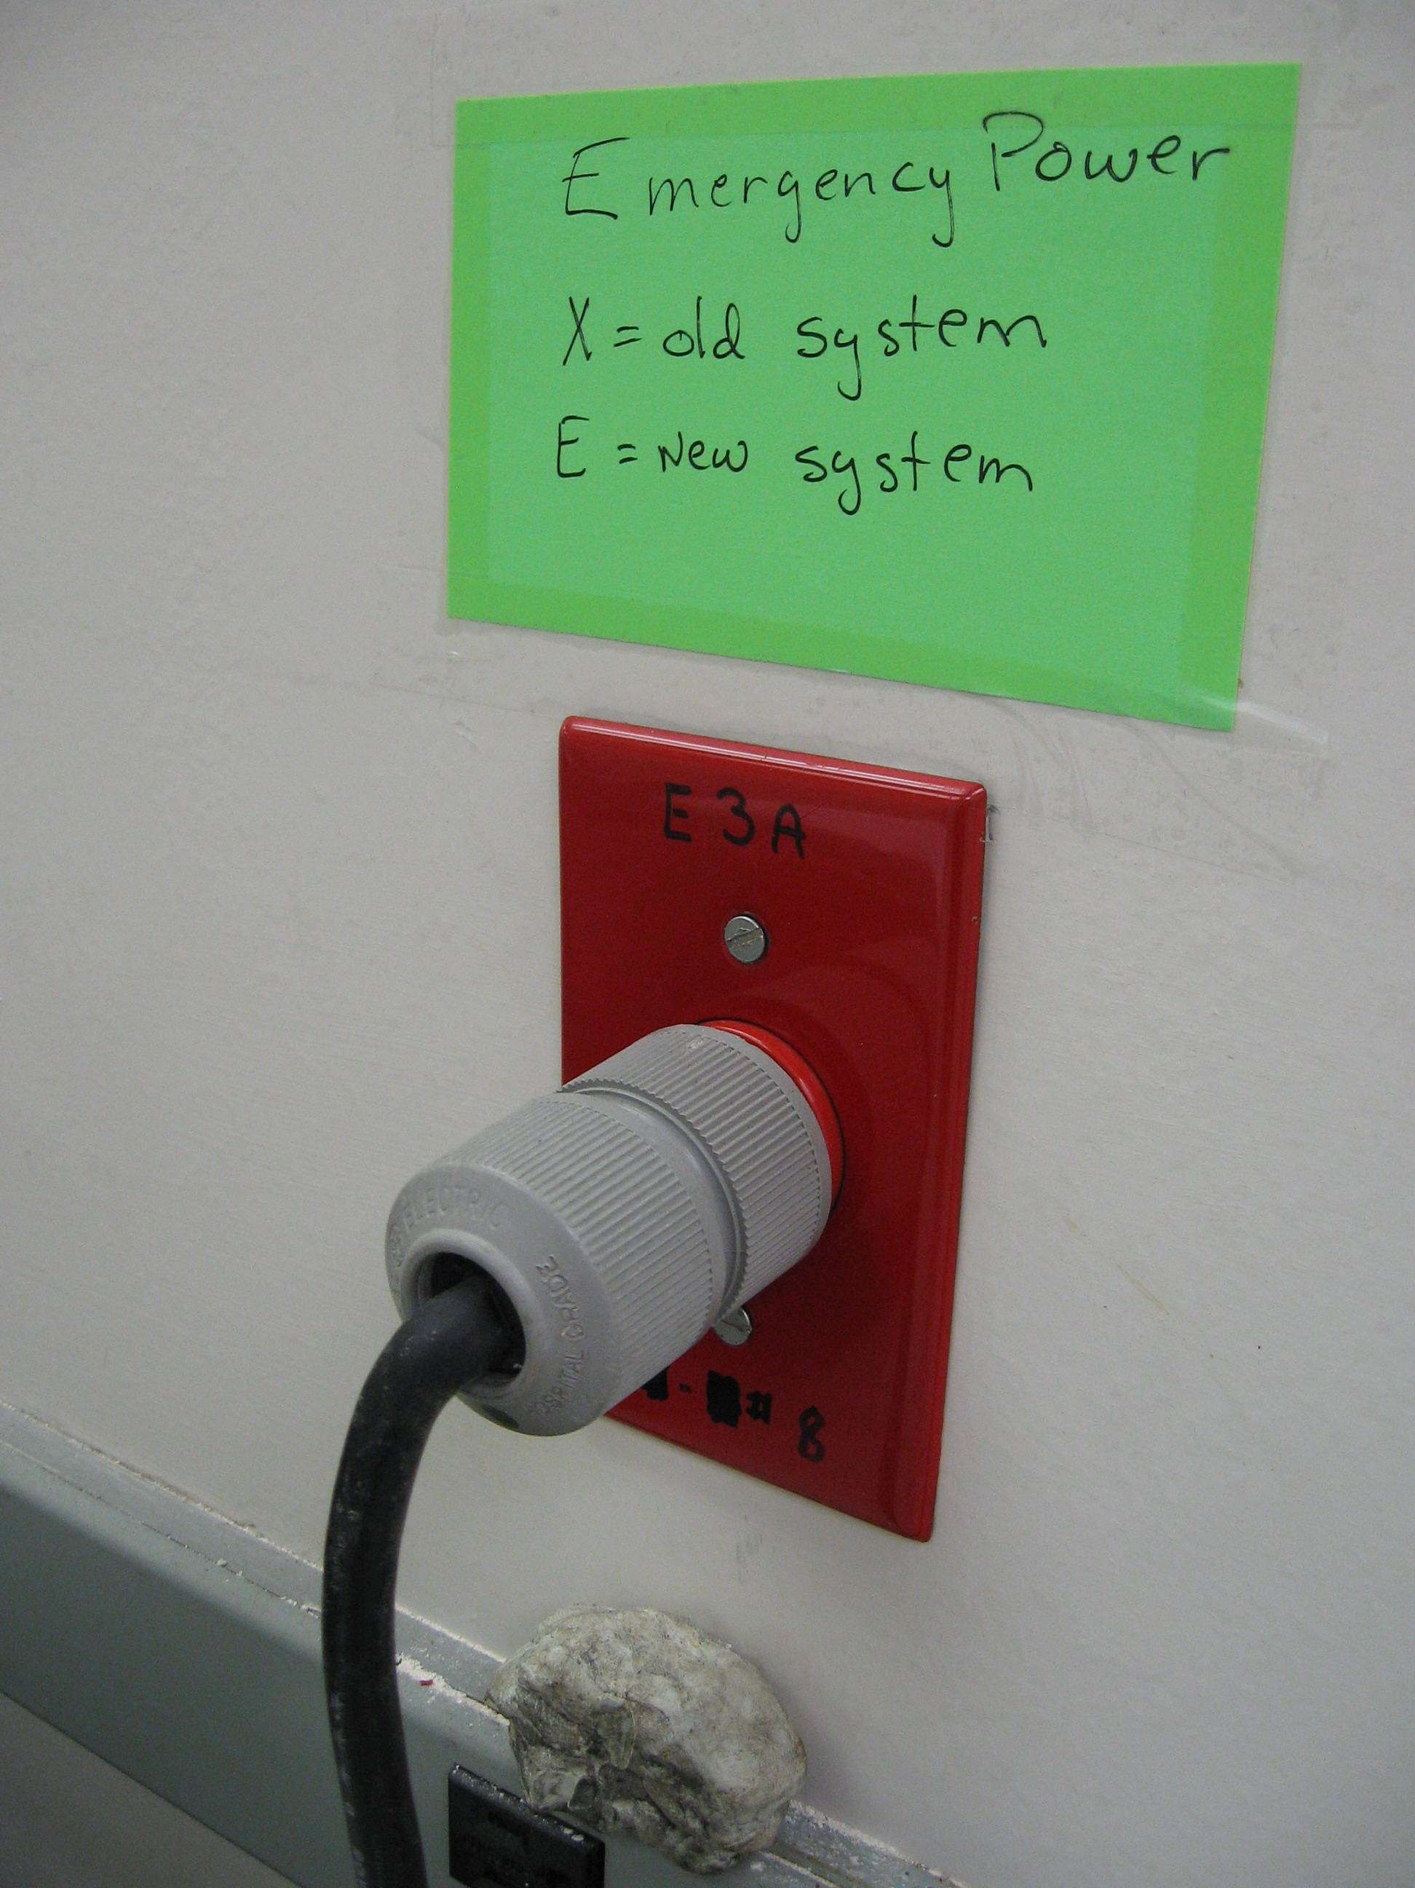 | Electrical Power Interruption  Electrical power disruption accounted for $20,000 worth direct losses in FY06. However this is not reflective of the loss of priceless research specimens. | Ensure that all critical equipment has backup power or has the ability to alert local personnel when power or temperature is disrupted. The production of duplicate or split samples is encouraged. Finally, some buildings are equipped with the necessary infrastructure to provide monitoring of temperature. | Contact Facilities Planning and Engineering for more information, (713)500-3498.

