REQUEST FOR PROPOSAL

The University of Texas Health Science Center at Houston

for

Supply Mall Vendors

RFP No.: 744-R1808 Supply Mall Vendors

Bid Submittal Deadline: Tuesday, April 10, 2018 at 2PM CST

Prepared By:
Martha G. Amaya, Purchasing Contracts Administrator
The University of Texas Health Science Center at Houston
1851 Crosspoint, OCB 1.160
Houston, Texas 77054
Buyer email: martha.g.amaya@uth.tmc.edu
March 9, 2018

Request for PROPOSAL

TABLE OF CONTENTS

SECTION 1: INTRODUCTION 3

SECTION 2: NOTICE TO PROPOSER 4

SECTION 3: SUBMISSION OF PROPOSAL 8

SECTION 4: TERMS AND CONDITIONS 10

SECTION 5: SPECIFICATIONS AND ADDITIONAL QUESTIONS 11

SECTION 6: PRICING AND DELIVERY SCHEDULE 13

Attachments:

APPENDIX ONE: PROPOSAL REQUIREMENTS

EXHIBIT A: SUPPLIER TOP 30 ITEMS (SEPARATE ATTACHMENT)

EXHIBIT B: CURRENT SUPPLY MALL ITEM EXAMPLES (SEPARATE ATTACHMENT)

SECTION 1

INTRODUCTION

  - Description of University

Founded in 1972, The University of Texas Health Science Center at Houston (UTHealth) is one of the fifteen component Universities of The University of Texas System. UTHealth is the most comprehensive academic health center in Texas, and is comprised of the following buildings & schools:

- Medical School (MSB) - 6431 Fannin Street
- Medical School Expansion (MSE) – 6431 Fannin Street
- Cyclotron Building (CYC) – 6431 Fannin Street
- School of Dentistry (SOD) – 7500 Cambridge Street
- School of Public Health (SPH) - 1200 Pressler Street
- School of Nursing (SON) – 6901 Bertner Avenue
- School of Biomedical Informatics (SBMI) - 7000 Fannin Street
- Graduate School of Biomedical Sciences (GSBS)– 6767 Bertner Avenue
- Biomedical & Behavioral Sciences Building (BBS) – 1941 East Road
- Institute of Molecular Medicine (IMM) – 1825 Pressler Street
- Harris County Psychiatric Center (HCPC) - 2800 South MacGregor Drive
- Operations Center Building (OCB) -1851 Cross Point Avenue
- University Center Tower (UCT) - 7000 Fannin Street
- Professional Building (UTPB) - 6410 Fannin Street
- Jesse H. Jones Library Building (JJL) – 1133 John Freeman Blvd.

UTHealth combines biomedical sciences, behavioral sciences, and the humanities to provide interdisciplinary activities essential to the definition of modern academic health science education. UTHealth is committed to providing health professional education and training for students, and is dedicated to providing excellence in research and patient care, which is offered through its clinics, Memorial Hermann Hospital System (its primary teaching hospital), and other affiliated institutions. UTHealth is a major part of the concentration of medical schools, hospitals and research facilities generally referred to as the Texas Medical Center.

The University of Texas Health Science Center at Houston System has nearly 6,500 employees and approximately 4,500 students. As a component of the University of Texas System, UTHealth is subject to the “Rules and Regulations of the Board of Regents of the University of Texas System for the government of The University of Texas System.”

An “Institutional Affiliate” means our affiliated Clinical practice, UT Physicians group, as designated by University, in connection with any Agreement.

1.2 Background and Special Circumstances

The UT Supply Mall is located in the McGovern Medical School at 6431 Fannin Street, Room B500, Houston, TX 77030. The UT Supply Mall is a self-service facility that provides stock items for sale in the general categories of chemicals, glassware, lab supplies, cryogens and other supplies. The UT Supply Mall is open 24/7 for authorized users. Items are not for sale to individuals or those outside of The University of Texas Health Science Center at Houston.

1.3 Objective of Request for Proposal

The University of Texas Health Science Center at Houston (University) is soliciting proposals from qualified vendors to provide commodity items for the UT Supply Mall. The University of Texas Health Science Center at Houston will be awarding multiple suppliers to stock products on a consignment basis at the UT Supply Mall. This is more specifically described in Section 5.4 (Scope of Work) of this Request for Proposal (RFP).

1.4 Group Purchase Authority

Texas law authorizes institutions of higher education (defined by §61.003, Education Code) to use the group purchasing procurement method (ref. §§51.9335, 73.115, and 74.008, Education Code). Additional Texas institutions of higher education may therefore elect to enter into a contract with the successful Proposer under this RFP. In particular, Proposer should note that University is part of The University of Texas System (UT System), which is comprised of fourteen institutions described at http://www.utsystem.edu/institutions. UT System institutions routinely evaluate whether a contract resulting from a procurement conducted by one of the institutions might be suitable for use by another, and if so, this RFP could give rise to additional purchase volumes. As a result, in submitting its proposal, Proposer should consider proposing a pricing model and other commercial terms that take into account the higher volumes and other expanded opportunities that could result from the eventual inclusion of other institutions in the purchase contemplated by this RFP. Any purchases made by other institutions based on this RFP will be the sole responsibility of those institutions.
SECTION 2

NOTICE TO PROPOSER

2.1 Submittal Deadline

University will accept proposals until 2:00 p.m. Central Time, on April 10, 2018 (Submittal Deadline).

2.2 RFP Contact Information and Questions

Interested parties may direct questions about this RFP to:

The University of Texas Health Science Center at Houston
Procurement Services
1851 Crosspoint, OCB1.160
Houston, Texas 77054
Martha G. Amaya

Email to: Martha.g.amaya@uth.tmc.edu
Subject Line: RFP No. 744-R1808

University instructs interested parties to restrict all contact and questions regarding this RFP to written communications delivered (i) in accordance with this Section on or before 12:00 PM CST, Tuesday, March 27, 2018 (Question Deadline), or (ii) if questions relate to Historically Underutilized Businesses, in accordance with Section 2.5.

University will provide responses as soon as practicable following the Question Deadline. University intends to respond to all timely submitted questions. However, University reserves the right to decline to respond to any question.

2.3 Criteria for Selection

The successful Proposer, if any, selected by University through this RFP will be the Proposer that submits a proposal on or before the Submittal Deadline that is the most advantageous to University. Contractor means the successful Proposer under this RFP.

Proposer is encouraged to propose terms and conditions offering the maximum benefit to University in terms of (1) service, (2) total overall cost, and (3) project management expertise.

The evaluation of proposals and the selection of Contractor will be based on the information provided in the proposal. University may consider additional information if University determines the information is relevant.

Criteria to be considered by University in evaluating proposals and selecting Contractor will be these factors:

    - Scored Criteria

Experience on Inventory

Pricing

Quality

2.4 Key Events Schedule

Date RFP Issued March 9, 2018

Pre-Proposal Conference March 20, 2018 at 1:00 PM CST
(ref. Section 2.6)

Question Deadline March 27, 2018, 12:00 PM CST
(ref. Section 2.2)

Submittal Deadline April 10, 2018, 2:00 PM CST
(ref. Section 2.1)

2.5 Historically Underutilized Businesses

2.5.1 All agencies of the State of Texas are required to make a good faith effort to assist historically underutilized businesses (HUBs) in receiving contract awards. The goal of the HUB program is to promote full and equal business opportunity for all businesses in contracting with state agencies. Pursuant to the HUB program, if under the terms of any agreement or contractual arrangement resulting from this RFP, Contractor subcontracts any Work, then Contractor must make a good faith effort to utilize HUBs certified by the Procurement and Support Services Division of the Texas Comptroller of Public Accounts. Proposals that fail to comply with the requirements contained in this Section 2.5 will constitute a material failure to comply with advertised specifications and will be rejected by University as non-responsive. Additionally, compliance with good faith effort guidelines is a condition precedent to awarding any agreement or contractual arrangement resulting from this RFP. Proposer acknowledges that, if selected by University, its obligation to make a good faith effort to utilize HUBs when subcontracting any Work will continue throughout the term of all agreements and contractual arrangements resulting from this RFP. Furthermore, any subcontracting of Work by the Proposer is subject to review by University to ensure compliance with the HUB program.

2.5.2 University has reviewed this RFP in accordance with 34 TAC §20.285, and has determined that subcontracting opportunities are not probable under this RFP.

2.6 Pre-Proposal Conference

University will host a pre-proposal conference at the date, time and location provided below. The pre-proposal conference will allow all Proposers an opportunity to ask University’s representatives relevant questions and clarify provisions of this RFP.

Date and Time: Tuesday, March 20, 2018 at 1:00 PM CST

Location: McGovern Medical School
6431 Fannin Street, Room B500, Houston, TX 77030

SECTION 3

SUBMISSION OF PROPOSAL

3.1 Number of Copies

Proposer must submit FIVE (5) complete paper copy of its entire proposal. An original signature by an authorized officer of Proposer must appear on the Execution of Offer (ref. Section 2 of APPENDIX ONE) of at least one (1) copy of the submitted proposal. The copy of the Proposer’s proposal bearing an original signature should contain the mark “original” on the front cover of the proposal. An original signature by an authorized officer of Proposer must appear on the Execution of Offer (ref. Section 2 of APPENDIX ONE) of at least one (1) copy of the submitted proposal. The copy of the Proposer’s proposal bearing an original signature should contain the mark “original” on the front cover of the proposal.

3.2 Submission

Proposals must be received by University on or before the Submittal Deadline (ref. Section 2.1) and delivered to:

The University of Texas Health Science Center at Houston
Procurement Services
1851 Crosspoint, OCB1.160
Houston, TX 77054
Attn: Martha G. Amaya

University will not acknowledge or receive Proposals that are delivered by telephone, facsimile (fax), or electronic mail (e-mail).

3.3 Proposal Validity Period

Each proposal must state that it will remain valid for University’s acceptance for a minimum of One Hundred Twenty (120) days after the Submittal Deadline, to allow time for evaluation, selection, and any unforeseen delays.

3.4 Terms and Conditions

3.4.1 Proposer must comply with the requirements and specifications contained in this RFP, including the Notice to Proposer (ref. Section 2), Proposal Requirements (ref. APPENDIX ONE) and the Specifications and Additional Questions (ref. Section 5). If there is a conflict among the provisions in this RFP, the provision requiring Proposer to supply the better quality or greater quantity of services will prevail, or if such conflict does not involve quality or quantity, then interpretation will be in the following order of precedence:

3.4.1.1 Specifications and Additional Questions (ref. Section 5);

3.4.1.2 Proposal Requirements (ref. APPENDIX ONE);

3.4.1.3 Notice to Proposers (ref. Section 2).

3.5 Submittal Checklist

Proposer is instructed to complete, sign, and return the following documents as a part of its proposal. If Proposer fails to return each of the following items with its proposal, then University may reject the proposal:

3.5.1 Signed and Completed Execution of Offer (ref. Section 2 of APPENDIX ONE)

3.5.2 Signed and Completed Pricing and Delivery Schedule (ref. Section 6)

3.5.3 Responses to Proposer's General Questionnaire (ref. Section 3 of APPENDIX ONE)

3.5.4 Signed and Completed Addenda Checklist (ref. Section 4 of APPENDIX ONE)

3.5.5 Responses to questions and requests for information in the Specifications and Additional Questions Section (ref. Section 5)

SECTION 4

GENERAL TERMS AND CONDITIONS

The terms and conditions contained in the Agreement or, in the sole discretion of University, terms and conditions substantially similar to those contained in the Agreement, will constitute and govern any agreement that results from this RFP. If Proposer takes exception to any terms or conditions set forth in the Agreement, Proposer will submit a list of the exceptions as part of its proposal. Proposer’s exceptions will be reviewed by University and may result in disqualification of Proposer’s proposal as non-responsive to this RFP. If Proposer’s exceptions do not result in disqualification of Proposer’s proposal, then University may consider Proposer’s exceptions when University evaluates the Proposer’s proposal.

SECTION 5

SPECIFICATIONS AND ADDITIONAL QUESTIONS

5.1 General

Minimum requirements and specifications for Work, as well as certain requests for information to be provided by Proposer as part of its proposal, are set forth below. As indicated in Section 2.3, Contractor means the successful Proposer.

5.2 Minimum Requirements

    - Suppliers are required to submit a list of their top 30 products they would like to sell at the Supply Mall. Please use EXHIBIT A and populate the item information requested. The items listed in EXHIBIT B provide an example of some of our top selling items.

    - The vendor must demonstrate knowledge of UT Supply Mall products.

    - Supplier must be able to accept electronic payments from the University for purchased goods.

    - Replenishment supplies are to be delivered during normal working hours (8:00 AM to 4:00 PM) Monday through Friday.

    - Successful Bidder is responsible for notifying UTHealth of any shortage of product listed herein within 48 hours of becoming aware of same.
    - Supplier’s representative shall meet with University’s designated representative on a monthly basis to review product utilization, expired product and purchase volume versus the expected turns.

    - Awarded suppliers will be paying an annual fee for the spaced used at the Supply Mall.

    - Supplier will fix pricing each calendar year. Any price increases must be mutually agreed upon.

5.3 Additional Questions Specific to this RFP

Proposer must submit the following information as part of Proposer’s proposal:

    - What is your company’s background with supply mall products?

    - Do you currently supply any supply malls?

    - What is your customer service response structure?

    - What would be the process on selecting supply mall products?

    - What is your experience in providing these type of supplies to a University of our size?

    - What type of supplies do you plan to stock in the cabinets?

    - What type of supplies do you plan to stock in the refrigerator/freezer?

    - Describe what difficulties you anticipate with this contract, and how you plan to manage these?

    - Do you acknowledge to take responsibility of any expired inventory? YES /NO

    - Do you acknowledge that once a month inventory will need to be restocked? YES /NO

    - Do you acknowledge that prices needs to be lower than what we currently pay? YES /NO

    - Do you acknowledge that there is a lease fee that must be paid on an annual basis? YES /NO

    - Does company accept electronic payments? YES /NO

5.4 Scope of Work

The purpose of this Request for Proposal (RFP) is seeking proposals from qualified suppliers that can provide supplies/products for our UT Supply Mall on a consignment basis. The mission of the UT Supply Mall is to provide a ready supply of commonly used products on-site to allow for convenient on-site procurement.

UT Supply Mall is a self-service facility furnished with twelve automated dispensing cabinets provided by UTHealth, and ten refrigerators/freezers provided by suppliers (see page 15 for pictures of the Supply Mall). Currently the UT Supply Mall stores chemicals, glassware, lab supplies, cryogens and other supplies. The equipment is system controlled and provides centralized management of user access, charge account and product inventory. Supply Mall users require security access in order to purchase items from the Supply Mall. Once access is granted a unique user ID and password is provided. Each user account is associated with a specific funding source, allowing for multiple accounts per user. Charges are applied upon removal of product from the dispensing units and are based on which account the user logs in with.

Users can look up current inventory by going to the UT Supply Mall website were an inventory report is posted every week or they can use the on-site embedded computer located in Supply Mall. Once the user has decided, which product is going to be purchased he/she will have to log in to the computer web based software and pick the product. Upon product removal, a transaction is recorded and included in a nightly consumption report submitted to the University. The consumption report is used to build payment transactions which are paid to suppliers for product removed from the dispensing units within the previous two-week period. Electronic payments are processed on the 1st and 16th of each month. Payment and consumption information is provided shortly thereafter to Suppliers for reconciliation.

The management system also provides restocking and cycle counting reporting features. Replenishment reports are submitted to Suppliers on a scheduled basis and can be triggered by minimum and maximum depletion settings. Suppliers ship restock products directly to the Supply Mall and are loaded into dispensing units by Supply Mall representatives. Restock products are considered consignment merchandise and remain the property of the Suppliers until they are removed from the dispensing units. Replenishment reports are not considered University requests. They are not Purchase Orders and no Invoices should be created against the reports or charged to the University. Suppliers are advised to utilize the Replenishment and Consumption reports along with the Payment information provided by University to reconcile Supply Mall purchases.

The UT Supply Mall is located in the McGovern Medical School at 6431 Fannin Street, Room B500, Houston, TX 77030. The UT Supply Mall is open 7 days a week 24 hours a day.

5.4.1 Supplier Product Offering. The Supplier agrees to furnish and deliver its products to 6431 Fannin Room B.500 Houston, Texas 77030 on a consignment basis. All inventory item additions and deletions must be pre-approved by University. University reserves the right to limit or restrict certain commodities for a Supplier. Supplier will provide an electronic file (excel format provided by University) for inventory items to be stocked in the UT Supply Mall. All University Medical School Building supplier managed inventory programs, including, but not limited to, freezer programs, consignment products, etc. will be centralized through the UT Supply Mall, located in the basement of the McGovern Medical School Building. Supplier assumes all risk for inventory shrinkage for this consignment inventory. Suppliers are require to provide a list of their top 30 items, attached as EXHIBIT A. Please include items where UTHealth will benefit from not paying shipping.

    - Equipment. University will provide space in the UT Supply Mall for Supplier to place consignment inventory for sale to the University. If such space is for room temperature items (non-perishable), University will provide cabinet space with locks. If such space is for a freezer or refrigerator (perishable products), Supplier will provide such freezer or refrigerator at Suppliers expense that accept an automated locking mechanism, which will be supplied by the University. This locking mechanism will be installed using adhesive strips and may require the removal of some handles to install. University will not be responsible for any damage as a result of installing this locking mechanism.

    - Lease Space. A lease space in the UT Supply Mall is defined as follows:
- Dry Goods Cabinet. University furnished approximately 79"H x 26'W x 28'D. The lease charge per cabinet is $ 150.00 per month.
- Freezer. Supplier furnished, cannot exceed 32"W and 110V without prior approval of the University. Locking mechanism required for each door per lease space. The lease charge per freezer is $ 150.00 per month.
- Refrigerator. Supplier furnished, cannot exceed 32'W and 110V without prior approval of the University. Locking mechanism required for each door per lease space. The lease charge per refrigerator is $ 150.00 per month. ($ 175.00 per month if unit is a refrigerator/freezer vertical combination unit due to additional locking mechanism). Lease periods are on an annual basis; therefore, no prorated refund upon termination by a Supplier. In addition, there will be a $400.00 administrative fee assessed to Supplier for early termination.

    - Benefits of the Supply Mall Program. UT Supply Mall Suppliers will average a 15% increase in sales. Suppliers will also have exposure to “New Lab” startups. A guarantee kick off vendor show within the first six months then annually thereafter. UT Health will also assist in marketing shows by: posting to UT Health website, notifying department leads, and featuring in UT Health newsletter. UT Health will commit to promote and enhance the UT Supply Mall program. Some examples include inventory management processes to enhance the visibility of inventory for our researchers. Our goal is to build a better partnership with our UT Supply Mall suppliers.

    - Return. Products on Consignment may be returned at University’s request with no exceptions.

    - Supplier’s Representations and Warranties. The Supplier represents and warrants to the University as follows: All products on Consignment shall be new and unused and shall have received all applicable approvals. The Supplier will comply with all federal, state and local laws, regulations and orders applicable to the manufacture, sale, packaging, labeling and delivery of the products on Consignment. Title to all of the Products on Consignment shall pass to the University in accordance with the terms hereof free and clear of all liens, claims and encumbrances whatsoever.

Supply Mall

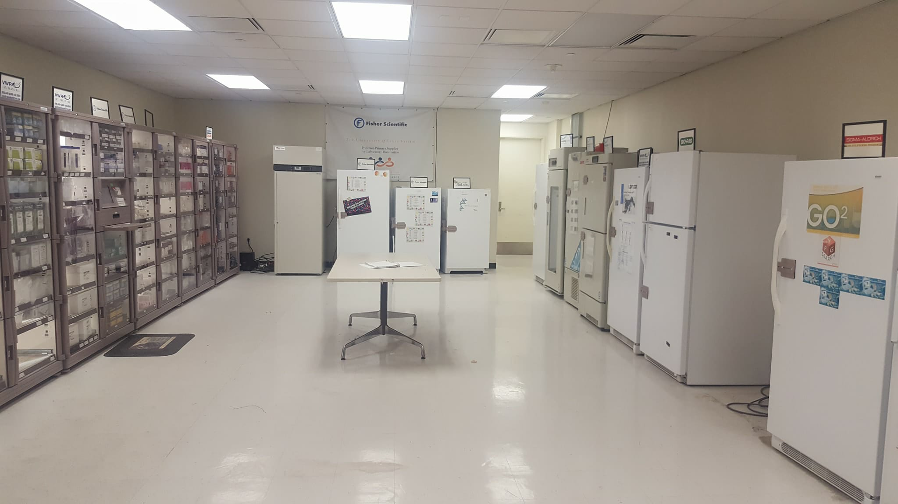

Cabinets Refrigerator Freezer

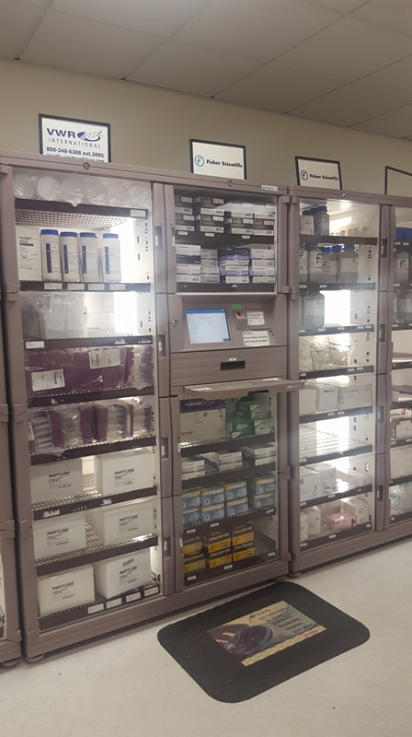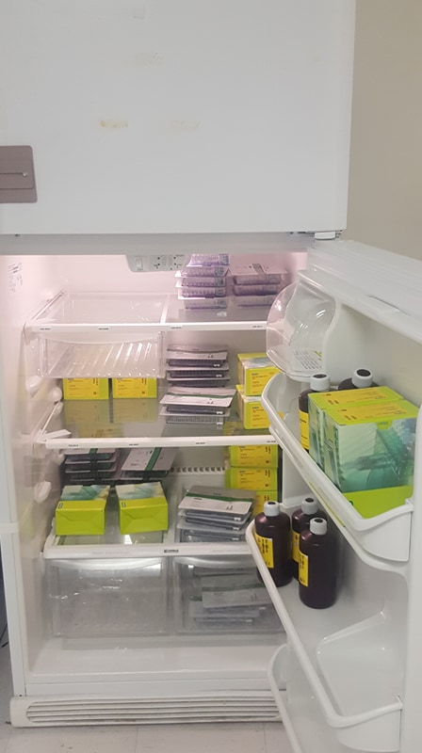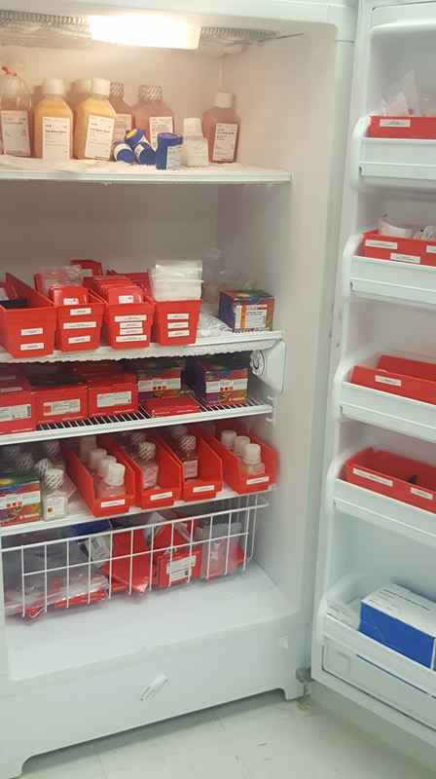

SECTION 6

PRICING AND DELIVERY SCHEDULE

Proposal of: ___________________________________
(Proposer Name)

To: The University of Texas Health Science Center at Houston

RFP No.: 744-R1808 Supply Mall Vendors

Ladies and Gentlemen:

Having examined specifications and requirements of this RFP (including attachments), the undersigned proposes to furnish Work upon the pricing terms quoted below:

6.1 Term of Agreement

University anticipates that the term of the Agreement may be up to 5 years with potential renewals. The initial term of the Agreement proposed to begin on July 1, 2018, and proposed to expire on July 1, 2023.

6.2 Pricing for Work and Expenses

See Exhibit A.

6.3 Discounts

Describe all discounts that may be available to University, including educational, federal, state and local discounts.

6.4 Schedule for Completion of Tasks and Submittal of Deliverables

Supplier must have their products in supply mall by July 1, 2018.
Calendar days to stock cabinets and or freezers ____________________.

6.5 Payment Terms

University’s standard payment terms are “net 30 days” as mandated by the Texas Prompt Payment Act (ref. Chapter 2251, Government Code).

Section 51.012, Education Code, authorizes University to make payments through electronic funds transfer methods. Respondent agrees to accept payments from University through those methods, including the automated clearing house system (ACH). Respondent agrees to provide Respondent’s banking information to University in writing on Respondent letterhead signed by an authorized representative of Respondent. Prior to the first payment, University will confirm Respondent’s banking information. Changes to Respondent’s bank information must be communicated to University in writing at least thirty (30) days before the effective date of the change and must include an IRS Form W-9 signed by an authorized representative of Respondent.

University, an agency of the State of Texas, is exempt from Texas Sales & Use Tax on goods and services in accordance with §151.309, Tax Code, and Title 34 TAC §3.322. Pursuant to 34 TAC §3.322(c)(4), University is not required to provide a tax exemption certificate to establish its tax exempt status.

Respectfully submitted,

Proposer: ____________________________

By: ___________________________
(Authorized Signature for Proposer)
Name: _________________________

Title: __________________________

Date: _____________________

APPENDIX ONE

PROPOSAL REQUIREMENTS

TABLE OF CONTENTS

SECTION 1: GENERAL INFORMATION 16

SECTION 2: EXECUTION OF OFFER 19

SECTION 3: PROPOSER'S GENERAL QUESTIONNAIRE 22

SECTION 4: ADDENDA CHECKLIST 24

SECTION 1

GENERAL INFORMATION

1.1 Purpose

University is soliciting competitive sealed proposals from Proposers having suitable qualifications and experience providing services in accordance with the terms, conditions and requirements set forth in this RFP. This RFP provides sufficient information for interested parties to prepare and submit proposals for consideration by University.

By submitting a proposal, Proposer certifies that it understands this RFP and has full knowledge of the scope, nature, quality, and quantity of services to be performed, the detailed requirements of services to be provided, and the conditions under which services are to be performed. Proposer also certifies that it understands that all costs relating to preparing a response to this RFP will be the sole responsibility of the Proposer.

PROPOSER IS CAUTIONED TO READ THE INFORMATION CONTAINED IN THIS RFP CAREFULLY AND TO SUBMIT A COMPLETE RESPONSE TO ALL REQUIREMENTS AND QUESTIONS AS DIRECTED.

1.2 Inquiries and Interpretations

University may in its sole discretion respond in writing to written inquiries concerning this RFP and mail its response as an Addendum to all parties recorded by University as having received a copy of this RFP. Only University’s responses that are made by formal written Addenda will be binding on University. Any verbal responses, written interpretations or clarifications other than Addenda to this RFP will be without legal effect. All Addenda issued by University prior to the Submittal Deadline will be and are hereby incorporated as a part of this RFP for all purposes.

Proposers are required to acknowledge receipt of each Addendum as specified in this Section. The Proposer must acknowledge all Addenda by completing, signing and returning the Addenda Checklist (ref. Section 4 of APPENDIX ONE). The Addenda Checklist must be received by University prior to the Submittal Deadline and should accompany the Proposer’s proposal.

Any interested party that receives this RFP by means other than directly from University is responsible for notifying University that it has received an RFP package, and should provide its name, address, telephone and facsimile (FAX) numbers, and email address, to University, so that if University issues Addenda to this RFP or provides written answers to questions, that information can be provided to that party.

1.3 Public Information

Proposer is hereby notified that University strictly adheres to all statutes, court decisions and the opinions of the Texas Attorney General with respect to disclosure of public information.

University may seek to protect from disclosure all information submitted in response to this RFP until such time as a final agreement is executed.

Upon execution of a final agreement, University will consider all information, documentation, and other materials requested to be submitted in response to this RFP, to be of a non-confidential and non-proprietary nature and, therefore, subject to public disclosure under the Texas Public Information Act (ref. Chapter 552, Government Code). Proposer will be advised of a request for public information that implicates their materials and will have the opportunity to raise any objections to disclosure to the Texas Attorney General. Certain information may be protected from release under §§552.101, 552.104, 552.110, 552.113, and 552.131, Government Code.

1.4 Type of Agreement

Contractor, if any, will be required to enter into a contract with University in a form substantially similar to the Agreement between University and Contractor, and otherwise acceptable to University in all respects (Agreement).

1.5 Proposal Evaluation Process

University will select Contractor by using the competitive sealed proposal process described in this Section. Any proposals that are not submitted by the Submittal Deadline or that are not accompanied by required number of completed and signed originals of the HSP will be rejected by University as non-responsive due to material failure to comply with this RFP (ref. Section 2.5.4). Upon completion of the initial review and evaluation of proposals, University may invite one or more selected Proposers to participate in oral presentations. University will use commercially reasonable efforts to avoid public disclosure of the contents of a proposal prior to selection of Contractor.

University may make the selection of Contractor on the basis of the proposals initially submitted, without discussion, clarification or modification. In the alternative, University may make the selection of Contractor on the basis of negotiation with any of the Proposers. In conducting negotiations, University will use commercially reasonable efforts to avoid disclosing the contents of competing proposals.

University may discuss and negotiate all elements of proposals submitted by Proposers within a specified competitive range. For purposes of negotiation, University may establish, after an initial review of the proposals, a competitive range of acceptable or potentially acceptable proposals composed of the highest rated proposal(s). In that event, University may defer further action on proposals not included within the competitive range pending the selection of Contractor; provided, however, University reserves the right to include additional proposals in the competitive range if deemed to be in the best interest of University.

After the Submittal Deadline but before final selection of Contractor, University may permit Proposer to revise its proposal in order to obtain the Proposer's best and final offer. In that event, representations made by Proposer in its revised proposal, including price and fee quotes, will be binding on Proposer. University will provide each Proposer within the competitive range with an equal opportunity for discussion and revision of its proposal. University is not obligated to select the Proposer offering the most attractive economic terms if that Proposer is not the most advantageous to University overall, as determined by University.

University reserves the right to (a) enter into an agreement for all or any portion of the requirements and specifications set forth in this RFP with one or more Proposers, (b) reject any and all proposals and re-solicit proposals, or (c) reject any and all proposals and temporarily or permanently abandon this selection process, if deemed to be in the best interests of University. Proposer is hereby notified that University will maintain in its files concerning this RFP a written record of the basis upon which a selection, if any, is made by University.

1.6 Proposer's Acceptance of RFP Terms

Proposer (1) accepts [a] Proposal Evaluation Process (ref. Section 1.5 of APPENDIX ONE), [b] Criteria for Selection (ref. Section 2.3), [c] Specifications and Additional Questions (ref. Section 5), [d] terms and conditions of the Agreement, and [e] all other requirements and specifications set forth in this RFP; and (2) acknowledges that some subjective judgments must be made by University during this RFP process.

1.7 Solicitation for Proposal and Proposal Preparation Costs

Proposer understands and agrees that (1) this RFP is a solicitation for proposals and University has made no representation written or oral that one or more agreements with University will be awarded under this RFP; (2) University issues this RFP predicated on University’s anticipated requirements for Work, and University has made no representation, written or oral, that any particular scope of work will actually be required by University; and (3) Proposer will bear, as its sole risk and responsibility, any cost that arises from Proposer’s preparation of a proposal in response to this RFP.

1.8 Proposal Requirements and General Instructions

1.8.1 Proposer should carefully read the information contained herein and submit a complete proposal in response to all requirements and questions as directed.

1.8.2 Proposals and any other information submitted by Proposer in response to this RFP will become the property of University.

1.8.3 University will not provide compensation to Proposer for any expenses incurred by the Proposer for proposal preparation or for demonstrations or oral presentations that may be made by Proposer. Proposer submits its proposal at its own risk and expense.

1.8.4 Proposals that (i) are qualified with conditional clauses; (ii) alter, modify, or revise this RFP in any way; or (iii) contain irregularities of any kind, are subject to disqualification by University, at University’s sole discretion.

1.8.5 Proposals should be prepared simply and economically, providing a straightforward, concise description of Proposer's ability to meet the requirements and specifications of this RFP. Emphasis should be on completeness, clarity of content, and responsiveness to the requirements and specifications of this RFP.

1.8.6 University makes no warranty or guarantee that an award will be made as a result of this RFP. University reserves the right to accept or reject any or all proposals, waive any formalities, procedural requirements, or minor technical inconsistencies, and delete any requirement or specification from this RFP or the Agreement when deemed to be in University's best interest. University reserves the right to seek clarification from any Proposer concerning any item contained in its proposal prior to final selection. Such clarification may be provided by telephone conference or personal meeting with or writing to University, at University’s sole discretion. Representations made by Proposer within its proposal will be binding on Proposer.

1.8.7 Any proposal that fails to comply with the requirements contained in this RFP may be rejected by University, in University’s sole discretion.

1.9 Preparation and Submittal Instructions

1.9.1 Specifications and Additional Questions

Proposals must include responses to the questions in Specifications and Additional Questions (ref. Section 5). Proposer should reference the item number and repeat the question in its response. In cases where a question does not apply or if unable to respond, Proposer should refer to the item number, repeat the question, and indicate N/A (Not Applicable) or N/R (No Response), as appropriate. Proposer should explain the reason when responding N/A or N/R.

1.9.2 Execution of Offer

Proposer must complete, sign and return the attached Execution of Offer (ref. Section 2 of APPENDIX ONE) as part of its proposal. The Execution of Offer must be signed by a representative of Proposer duly authorized to bind the Proposer to its proposal. Any proposal received without a completed and signed Execution of Offer may be rejected by University, in its sole discretion.

1.9.3 Pricing and Delivery Schedule

Proposer must complete and return the Pricing and Delivery Schedule (ref. Section 6), as part of its proposal. In the Pricing and Delivery Schedule, the Proposer should describe in detail (a) the total fees for the entire scope of Work; and (b) the method by which the fees are calculated. The fees must be inclusive of all associated costs for delivery, labor, insurance, taxes, overhead, and profit.

University will not recognize or accept any charges or fees to perform Work that are not specifically stated in the Pricing and Delivery Schedule.

In the Pricing and Delivery Schedule, Proposer should describe each significant phase in the process of providing Work to University, and the time period within which Proposer proposes to be able to complete each such phase.

1.9.4 Proposer’s General Questionnaire

Proposals must include responses to the questions in Proposer’s General Questionnaire (ref. Section 3 of APPENDIX ONE). Proposer should reference the item number and repeat the question in its response. In cases where a question does not apply or if unable to respond, Proposer should refer to the item number, repeat the question, and indicate N/A (Not Applicable) or N/R (No Response), as appropriate. Proposer should explain the reason when responding N/A or N/R.

1.9.5 Addenda Checklist

Proposer should acknowledge all Addenda to this RFP (if any) by completing, signing and returning the Addenda Checklist (ref. Section 4 of APPENDIX ONE) as part of its proposal. Any proposal received without a completed and signed Addenda Checklist may be rejected by University, in its sole discretion.

1.9.6 Submission

Proposer should submit all proposal materials as instructed in Section 3. RFP No. (ref. Title Page) and Submittal Deadline (ref. Section 2.1) should be clearly shown (1) in the Subject line of any email transmitting the proposal, and (2) in the lower left-hand corner on the top surface of any envelope or package containing the proposal. In addition, the name and the return address of the Proposer should be clearly visible in any email or on any envelope or package.

Proposer must also submit the HUB Subcontracting Plan (also called the HSP) as required by Section 2.6.

University will not under any circumstances consider a proposal that is received after the Submittal Deadline or which is not accompanied by the HSP as required by Section 2.6. University will not accept proposals submitted by telephone or FAX transmission.

Except as otherwise provided in this RFP, no proposal may be changed, amended, or modified after it has been submitted to University. However, a proposal may be withdrawn and resubmitted at any time prior to the Submittal Deadline. No proposal may be withdrawn after the Submittal Deadline without University’s consent, which will be based on Proposer's written request explaining and documenting the reason for withdrawal, which is acceptable to University.

SECTION 2

Execution of Offer

THIS EXECUTION OF OFFER MUST BE COMPLETED, SIGNED AND RETURNED WITH PROPOSER'S PROPOSAL. FAILURE TO COMPLETE, SIGN AND RETURN THIS EXECUTION OF OFFER WITH THE PROPOSER’S PROPOSAL MAY RESULT IN THE REJECTION OF THE PROPOSAL.

2.1 Representations and Warranties. Proposer represents, warrants, certifies, acknowledges, and agrees as follows:

2.1.1 Proposer will furnish Work to University and comply with all terms, conditions, requirements and specifications set forth in this RFP and any resulting Agreement.

2.1.2 This RFP is a solicitation for a proposal and is not a contract or an offer to contract Submission of a proposal by Proposer in response to this RFP will not create a contract between University and Proposer. University has made no representation or warranty, written or oral, that one or more contracts with University will be awarded under this RFP. Proposer will bear, as its sole risk and responsibility, any cost arising from Proposer’s preparation of a response to this RFP.

2.1.3 Proposer is a reputable company that is lawfully and regularly engaged in providing Work.

2.1.4 Proposer has the necessary experience, knowledge, abilities, skills, and resources to perform Work.

2.1.5 Proposer is aware of, is fully informed about, and is in full compliance with all applicable federal, state and local laws, rules, regulations and ordinances relating to performance of Work.

2.1.6 Proposer understands (i) the requirements and specifications set forth in this RFP and (ii) the terms and conditions set forth in the Agreement under which Proposer will be required to operate.

2.1.7 Proposer will not delegate any of its duties or responsibilities under this RFP or the Agreement to any sub-contractor, except as expressly provided in the Agreement.

2.1.8 Proposer will maintain any insurance coverage required by the Agreement during the entire term.

2.1.9 All statements, information and representations prepared and submitted in response to this RFP are current, complete, true and accurate. University will rely on such statements, information and representations in selecting Contractor. If selected by University, Proposer will notify University immediately of any material change in any matters with regard to which Proposer has made a statement or representation or provided information.

2.1.10 Proposer will defend with counsel approved by University, indemnify, and hold harmless University, UT System, the State of Texas, and all of their regents, officers, agents and employees, from and against all actions, suits, demands, costs, damages, liabilities and other claims of any nature, kind or description, including reasonable attorneys’ fees incurred in investigating, defending or settling any of the foregoing, arising out of, connected with, or resulting from any negligent acts or omissions or willful misconduct of Proposer or any agent, employee, subcontractor, or supplier of Proposer in the execution or performance of any contract or agreement resulting from this RFP.

2.1.11 Pursuant to §§2107.008 and 2252.903, Government Code, any payments owing to Proposer under the Agreement may be applied directly to any debt or delinquency that Proposer owes the State of Texas or any agency of the State of Texas, regardless of when it arises, until such debt or delinquency is paid in full.

2.1.12 Any terms, conditions, or documents attached to or referenced in Proposer’s proposal are applicable to this procurement only to the extent that they (a) do not conflict with the laws of the State of Texas or this RFP, and (b) do not place any requirements on University that are not set forth in this RFP. Submission of a proposal is Proposer's good faith intent to enter into the Agreement with University as specified in this RFP and that Proposer’s intent is not contingent upon University's acceptance or execution of any terms, conditions, or other documents attached to or referenced in Proposer’s proposal.

2.1.13 Pursuant to Chapter 2270, Government Code, Proposer certifies Proposer (a) does not currently boycott Israel; and (b) will not boycott Israel during the Term of the Agreement. Proposer acknowledges the Agreement may be terminated and payment withheld if this certification is inaccurate.

2.1.14 Pursuant to Subchapter F, Chapter 2252, Government Code, Proposer certifies Proposer is not engaged in business with Iran, Sudan, or a foreign terrorist organization. Proposer acknowledges the Agreement may be terminated and payment withheld if this certification is inaccurate.

2.2 No Benefit to Public Servants. Proposer has not given or offered to give, nor does Proposer intend to give at any time hereafter, any economic opportunity, future employment, gift, loan, gratuity, special discount, trip, favor or service to a public servant in connection with its proposal. Failure to sign this Execution of Offer, or signing with a false statement, may void the submitted proposal or any resulting Agreement, and Proposer may be removed from all proposer lists at University.

2.3 Tax Certification. Proposer is not currently delinquent in the payment of any taxes due under Chapter 171, Tax Code, or Proposer is exempt from the payment of those taxes, or Proposer is an out-of-state taxable entity that is not subject to those taxes, whichever is applicable. A false certification will be deemed a material breach of any resulting contract or agreement and, at University's option, may result in termination of any resulting Agreement.

2.4 Antitrust Certification. Neither Proposer nor any firm, corporation, partnership or institution represented by Proposer, nor anyone acting for such firm, corporation or institution, has violated the antitrust laws of the State of Texas, codified in §15.01 et seq., Business and Commerce Code, or the Federal antitrust laws, nor communicated directly or indirectly the proposal made to any competitor or any other person engaged in such line of business.

2.5 Authority Certification. The individual signing this document and the documents made a part of this RFP, is authorized to sign the documents on behalf of Proposer and to bind Proposer under any resulting Agreement.

2.6 Child Support Certification. Under §231.006, Family Code, relating to child support, the individual or business entity named in Proposer’s proposal is not ineligible to receive award of the Agreement, and any Agreements resulting from this RFP may be terminated if this certification is inaccurate.

2.7 Relationship Certifications.
No relationship, whether by blood, marriage, business association, capital funding agreement or by any other such kinship or connection exists between the owner of any Proposer that is a sole proprietorship, the officers or directors of any Proposer that is a corporation, the partners of any Proposer that is a partnership, the joint venturers of any Proposer that is a joint venture, or the members or managers of any Proposer that is a limited liability company, on one hand, and an employee of any member institution of UT System, on the other hand, other than the relationships which have been previously disclosed to University in writing.
- Proposer has not been an employee of any member institution of UT System within the immediate twelve (12) months prior to the Submittal Deadline.
- No person who, in the past four (4) years served as an executive of a state agency was involved with or has any interest in Proposer’s proposal or any contract resulting from this RFP (ref. §669.003, Government Code).
- All disclosures by Proposer in connection with this certification will be subject to administrative review and approval before University enters into any Agreement resulting from this RFP with Proposer.

2.8 Compliance with Equal Employment Opportunity Laws. Proposer is in compliance with all federal laws and regulations pertaining to Equal Employment Opportunities and Affirmative Action.

2.9 Compliance with Safety Standards. All products and services offered by Proposer to University in response to this RFP meet or exceed the safety standards established and promulgated under the Federal Occupational Safety and Health Law (Public Law 91-596) and the Texas Hazard Communication Act, Chapter 502, Health and Safety Code, and all related regulations in effect or proposed as of the date of this RFP.

2.10 Exceptions to Certifications. Proposer will and has disclosed, as part of its proposal, any exceptions to the information stated in this Execution of Offer. All information will be subject to administrative review and approval prior to the time University makes an award or enters into any Agreement with Proposer.

2.11 Manufacturer Responsibility and Consumer Convenience Computer Equipment Collection and Recovery Act Certification. If Proposer will sell or lease computer equipment to University under any Agreement resulting from this RFP then, pursuant to §361.965(c), Health & Safety Code, Proposer is in compliance with the Manufacturer Responsibility and Consumer Convenience Computer Equipment Collection and Recovery Act set forth in Chapter 361, Subchapter Y, Health & Safety Code, and the rules adopted by the Texas Commission on Environmental Quality under that Act as set forth in 30 TAC Chapter 328. §361.952(2), Health & Safety Code, states that, for purposes of the Manufacturer Responsibility and Consumer Convenience Computer Equipment Collection and Recovery Act, the term “computer equipment” means a desktop or notebook computer and includes a computer monitor or other display device that does not contain a tuner.

2.12 Conflict of Interest Certification.
- Proposer is not a debarred vendor or the principal of a debarred vendor (i.e. owner, proprietor, sole or majority shareholder, director, president, managing partner, etc.) either at the state or federal level.
- Proposer’s provision of services or other performance under any Agreement resulting from this RFP will not constitute an actual or potential conflict of interest.
- Proposer has disclosed any personnel who are related to any current or former employees of University.
- Proposer has not given, nor does Proposer intend to give, at any time hereafter, any economic opportunity, future employment, gift, loan, gratuity, special discount, trip, favor or service to an officer or employee of University in connection with this RFP.

2. 13 Proposer should complete the following information:

If Proposer is a Corporation, then State of Incorporation:

If Proposer is a Corporation then Proposer’s Corporate Charter Number: ______

RFP No.: 744-R1808

NOTICE: With few exceptions, individuals are entitled on request to be informed about the information that governmental bodies of the State of Texas collect about such individuals. Under §§552.021 and 552.023, Government Code, individuals are entitled to receive and review such information. Under §559.004, Government Code, individuals are entitled to have governmental bodies of the State of Texas correct information about such individuals that is incorrect.

Submitted and Certified By:

(Proposer Institution’s Name)

(Signature of Duly Authorized Representative)

(Printed Name/Title)

(Date Signed)

(Proposer’s Street Address)

(City, State, Zip Code)

(Telephone Number)

(FAX Number)

(Email Address)

SECTION 3

PROPOSER’S GENERAL QUESTIONNAIRE

NOTICE: With few exceptions, individuals are entitled on request to be informed about the information that governmental bodies of the State of Texas collect about such individuals. Under §§552.021 and 552.023, Government Code, individuals are entitled to receive and review such information. Under §559.004, Government Code, individuals are entitled to have governmental bodies of the State of Texas correct information about such individuals that is incorrect.

Proposals must include responses to the questions contained in this Proposer’s General Questionnaire. Proposer should reference the item number and repeat the question in its response. In cases where a question does not apply or if unable to respond, Proposer should refer to the item number, repeat the question, and indicate N/A (Not Applicable) or N/R (No Response), as appropriate. Proposer will explain the reason when responding N/A or N/R.

3.1 Proposer Profile

3.1.1 Legal name of Proposer company:

Address of principal place of business:

Address of office that would be providing service under the Agreement:

Number of years in Business:

State of incorporation:

Number of Employees:

Annual Revenues Volume:

Name of Parent Corporation, if any ______________________________
NOTE: If Proposer is a subsidiary, University prefers to enter into a contract or agreement with the Parent Corporation or to receive assurances of performance from the Parent Corporation.

3.1.2 State whether Proposer will provide a copy of its financial statements for the past two (2) years, if requested by University.

3.1.3 Proposer will provide a financial rating of the Proposer entity and any related documentation (such as a Dunn and Bradstreet analysis) that indicates the financial stability of Proposer.

3.1.4 Is Proposer currently for sale or involved in any transaction to expand or to become acquired by another business entity? If yes, Proposer will explain the expected impact, both in organizational and directional terms.

3.1.5 Proposer will provide any details of all past or pending litigation or claims filed against Proposer that would affect its performance under the Agreement with University (if any).

3.1.6 Is Proposer currently in default on any loan agreement or financing agreement with any bank, financial institution, or other entity? If yes, Proposer will specify the pertinent date(s), details, circumstances, and describe the current prospects for resolution.

3.1.7 Proposer will provide a customer reference list of no less than three (3) organizations with which Proposer currently has contracts and/or to which Proposer has previously provided services (within the past five (5) years) of a type and scope similar to those required by University’s RFP. Proposer will include in its customer reference list the customer’s company name, contact person, telephone number, project description, length of business relationship, and background of services provided by Proposer.

3.1.8 Does any relationship exist (whether by family kinship, business association, capital funding agreement, or any other such relationship) between Proposer and any employee of University? If yes, Proposer will explain.

3.1.9 Proposer will provide the name and Social Security Number for each person having at least 25% ownership interest in Proposer. This disclosure is mandatory pursuant to §231.006, Family Code, and will be used for the purpose of determining whether an owner of Proposer with an ownership interest of at least 25% is more than 30 days delinquent in paying child support. Further disclosure of this information is governed by the Texas Public Information Act (ref. Chapter 552, Government Code), and other applicable law.

3.2 Approach to Work

3.2.1 Proposer will provide a statement of the Proposer’s service approach and will describe any unique benefits to University from doing business with Proposer. Proposer will briefly describe its approach for each of the required services identified in Section 5.4 Scope of Work of this RFP.

3.2.2 Proposer will provide an estimate of the earliest starting date for services following execution of the Agreement.

3.2.3 Proposer will submit a work plan with key dates and milestones. The work plan should include:

3.2.3.1 Identification of tasks to be performed;

3.2.3.2 Time frames to perform the identified tasks;

3.2.3.3 Project management methodology;

3.2.3.4 Implementation strategy; and

3.2.3.5 The expected time frame in which the services would be implemented.

3.2.4 Proposer will describe the types of reports or other written documents Proposer will provide (if any) and the frequency of reporting, if more frequent than required in this RFP. Proposer will include samples of reports and documents if appropriate.

3.3 General Requirements

3.3.1 Proposer will provide summary resumes for its proposed key personnel who will be providing services under the Agreement with University, including their specific experiences with similar service projects, and number of years of employment with Proposer.

3.3.2 Proposer will describe any difficulties it anticipates in performing its duties under the Agreement with University and how Proposer plans to manage these difficulties. Proposer will describe the assistance it will require from University.

3.4 Service Support

Proposer will describe its service support philosophy, how it is implemented, and how Proposer measures its success in maintaining this philosophy.

3.5 Quality Assurance

Proposer will describe its quality assurance program, its quality requirements, and how they are measured.

3.6 Miscellaneous

3.6.1 Proposer will provide a list of any additional services or benefits not otherwise identified in this RFP that Proposer would propose to provide to University. Additional services or benefits must be directly related to the goods and services solicited under this RFP.

3.6.2 Proposer will provide details describing any unique or special services or benefits offered or advantages to be gained by University from doing business with Proposer. Additional services or benefits must be directly related to the goods and services solicited under this RFP.

3.6.3 Does Proposer have a contingency plan or disaster recovery plan in the event of a disaster? If so, then Proposer will provide a copy of the plan.

SECTION 4

ADDENDA CHECKLIST

Proposal of: ___________________________________
(Proposer Name)

To: The University of Texas Health Science Center at Houston

RFP No.: 744-R1808 Supply Mall Vendors

Ladies and Gentlemen:

The undersigned Proposer hereby acknowledges receipt of the following Addenda to the captioned RFP (initial blanks for any Addenda issued).

No. 1 _____ No. 2 _____ No. 3 _____ No. 4 _____ No. 5 _____

Respectfully submitted,

Proposer: ________________________

By: ___________________________
(Authorized Signature for Proposer)

Name: _________________________

Title: __________________________

Date: _____________________

EXHIBIT A

SUPPLIERS TOP 30 ITEMS

(INCLUDED AS SEPARATE ATTACHMENT)

EXHIBIT B

SUPPLY MALL TOP SELLING ITEMS

(INCLUDED AS SEPARATE ATTACHMENT)

