REQUEST FOR PROPOSAL

The University of Texas Health Science Center at Houston

RFP No. 744-R1429: TX-KEA Mobile Technology

Pre-proposal Conference: July 30, 2014, 10:00 AM CST

Proposal and HUB Subcontracting Plan Deadline: August 22, 2014 at 11:00 AM CST

Prepared By:
LaChandra Wilson, Buyer II
The University of Texas Health Science Center at Houston
Procurement Services
1851 Crosspoint, Suite OCB 1.160
Houston, Texas 77054

E-mail: LaChandra.Wilson@uth.tmc.edu

July 22, 2014

Request for PROPOSAL

TABLE OF CONTENTS

SECTION 1: INTRODUCTION 3

SECTION 2: NOTICE TO PROPOSER 5

SECTION 3: SUBMISSION OF PROPOSAL 9

SECTION 4: GENERAL TERMS AND CONDITIONS 11

SECTION 5: SPECIFICATIONS AND ADDITIONAL QUESTIONS 12

SECTION 6: PRICING AND DELIVERY SCHEDULE 20

Attachments:

EXHIBIT A: EXAMPLES OF TEST TEMPLATES

APPENDIX ONE: PROPOSAL REQUIREMENTS

APPENDIX TWO: SAMPLE AGREEMENT (SEPARATE ATTACHMENT)

APPENDIX THREE: HUB SUBCONTRACTING PLAN (SEPARATE ATTACHMENT)

APPENDIX FOUR: INTENTIONALLY DELETED

APPENDIX FIVE: ACCESS BY INDIVIDUALS WITH DISABILITIES

APPENDIX SIX: ELECTRONIC AND INFORMATION RESOURCES ENVIRONMENT
SPECIFICATIONS

SECTION 1

INTRODUCTION

  - Description of University

Founded in 1972, The University of Texas Health Science Center at Houston (UTHSC-H) is one of the fifteen component Universities of The University of Texas System. UTHSC-H is the most comprehensive academic health center in Texas, and is comprised of the following buildings & schools:

- Medical School (MSB) - 6431 Fannin Street
- Medical School Expansion (MSE) - 6431 Fannin Street
- Cyclotron Building (CYC) - 6431 Fannin Street
- School of Dentistry (SOD) - 7500 Cambridge Street
- School of Public Health (SPH) - 1200 Pressler Street
- School of Nursing (SON) - 6901 Bertner Avenue
- School of Health Information Sciences (SHIS) - 7000 Fannin Street
- Graduate School of Biomedical Sciences (GSBS) - 6655 Travis Street
- Biomedical & Behavioral Sciences Building (BBS) - 1941 East Road
- Institute of Molecular Medicine (IMM) - 1825 Pressler Street
- Harris County Psychiatric Center (HCPC) - 2800 South MacGregor Drive
- Operations Center Building (OCB) -1851 Cross Point Avenue
- University Center Tower (UCT) - 7000 Fannin Street
- Professional Building (UTPB) - 6410 Fannin Street

UTHSC-H combines biomedical sciences, behavioral sciences, and the humanities to provide interdisciplinary activities essential to the definition of modern academic health science education. UTHSC-H is committed to providing health professional education and training for students, and is dedicated to providing excellence in research and patient care, which is offered through its clinics, Memorial Hermann Hospital System (its primary teaching hospital), and other affiliated institutions. UTHSC-H is a major part of the concentration of medical schools, hospitals and research facilities generally referred to as the Texas Medical Center.

The University of Texas Health Science Center at Houston System has nearly 4,500 employees and approximately 3,600 students. As a component of the University of Texas System, UTHSC-H is subject to the “Rules and Regulations of the Board of Regents of the University of Texas System for the government of The University of Texas System.”

1.2 Background and Special Circumstances

The following software technologies are the subject of this RFP.

Inquisit is a program for administering psychological experiments. It allows you to customize question properties and administration rules to fit a wide variety of tests—reference www.millisecond.com/products/Inquisit4/laboverview.aspx.

GuideVue® technology is proprietary to the University of Texas designed for the development of certain kinds of instructional and procedural apps—reference www.guidevue.com. The system has four components, all software:

- guideVue Author and PC Player- .NET Visual C# Sharp under Visual Studio
2008. MindFusion third party control for workflow layout.

2. a) guideVue iOS Player: Native on IOS SDK XCode 5.1. Custom user interface.

2. b) guideVue Android Player: Native on Android SDK, (KitKat and Jelly Bean
compatibility), custom user interface.

- guideVue PUBLISHER: Wordpress, with MySQL/PHP for Dynamic and
Secure pages.

- guideVue Reporter-PHP interface with SQL Server 2000 as backend
database.

In order to use the system, the User must install the GuideVue Author. Player apps can be downloaded for free from the Apple Store for iPod, iPad, and iPhone versions, or the Google Play store for the Android version.

Access to the Author software will be provided for reference to help develop a bid. The University will provide two (2) sets of usernames and passwords for each bidder that sends an email request to University Contact—see Section 2.2.

This bid will be based on time and materials.

1.3 Objective of this Request for Proposal

The University of Texas Health Science Center at Houston (“University”) is soliciting proposals from qualified vendors to perform software development services to meet the goals of the Texas Kindergarten Entry Assessment (TX-KEA) system: The purpose of this Project is twofold:

- Implement the assembly and integration of prototypes into final test versions for the Inquisit system. There is NO requirement for mobile devices in this part of the project.

- Augment or modify components of the guideVue system including the guideVue authoring software, the Player Apps, the REPORTER, and the PUBLISHER component.

Depending on the specific component, the Scope of Work includes a) designing the User interface, (b) coding, testing, debugging and delivering commercial-quality software, and (c) configuring components to access specific servers hosted by the University and/or the Texas Education Agency. These services are more specifically described in Section 5.4 (Scope of Work) of this RFP.

1.4 Group Purchase Authority

Texas law authorizes institutions of higher education (defined by Section 61.003, Education Code) to use the group purchasing procurement method (ref. Sections 51.9335, 73.115, and 74.008, Education Code). Additional Texas institutions of higher education may therefore elect to enter into a contract with the successful Proposer under this RFP.

SECTION 2

NOTICE TO PROPOSER

2.1 Submittal Deadline

University will accept proposals submitted in response to this RFP until 11:00 AM CST on Friday, August 22, 2014 (the “Submittal Deadline”).

2.2 University Contact Person

Proposers will direct all questions or concerns regarding this RFP to the following University contact (“University Contact”):

The University of Texas Health Science Center at Houston
Procurement Services
1851 Crosspoint, Suite OCB 1.160
Houston, Texas 77054
Email: LaChandra.Wilson@uth.tmc.edu
Attention: LaChandra Wilson

University specifically instructs all interested parties to restrict all contact and questions regarding this RFP to written communications forwarded to University Contact.

University Contact must receive all questions or concerns no later than 11:00 AM on Tuesday, August 12, 2014. University will have a reasonable amount of time to respond to questions or concerns. It is University’s intent to respond to all appropriate questions and concerns; however, University reserves the right to decline to respond to any question or concern.

2.3 Criteria for Selection

The successful Proposer, if any, selected by University in accordance with the requirements and specifications set forth in this RFP will be the Proposer that submits a proposal in response to this RFP on or before the Submittal Deadline that is the most advantageous to University. The successful Proposer is referred to as the “Contractor.”

Proposer is encouraged to propose terms and conditions offering the maximum benefit to University in terms of (1) services to University, (2) total overall cost to University, and (3) project management expertise. Proposers should describe all educational, state and local government discounts, as well as any other applicable discounts that may be available to University in a contract for the Services.

An evaluation team from University will evaluate proposals. The evaluation of proposals and the selection of Contractor will be based on the information provided by Proposer in its proposal. University may give consideration to additional information if University deems such information relevant.

The criteria to be considered by University in evaluating proposals and selecting Contractor, will be those factors listed below:

    - Scored Criteria

2.3.1.1 15% Experience. (Proposer’s successful performance of
project similar to Project in size and scope)
2.3.1.2 15% Management and Work Plan. (Proposer’s plan to
successfully complete Project)
2.3.1.3 40% Technical Qualifications. (Proposer’s possession of
skills necessary to implement plan)
2.3.1.4 30% Cost of services. (Proposer’s cost for services)

2.4 Key Events Schedule

Issuance of RFP July 22, 2014, 11:00 AM CST

Pre-proposal Conference July 30, 2014, 10:00 AM CST

Deadline for Questions August 12, 2014, 11:00 AM CST
(ref. Section 2.2 of this RFP)

HUB Subcontracting Plan Deadline August 22, 2014, 11:00 AM CST
(ref. Section 2.5 of this RFP)

Proposal Submittal Deadline August 22, 2014, 11:00 AM CST
(ref. Section 2.1 of this RFP)

2.5 Historically Underutilized Businesses

2.5.1 All agencies of the State of Texas are required to make a good faith effort to assist historically underutilized businesses (each a “HUB”) in receiving contract awards. The goal of the HUB program is to promote full and equal business opportunity for all businesses in contracting with state agencies. Pursuant to the HUB program, if under the terms of any agreement or contractual arrangement resulting from this RFP, Contractor subcontracts any of the Services, then Contractor must make a good faith effort to utilize HUBs certified by the Procurement and Support Services Division of the Texas Comptroller of Public Accounts. Proposals that fail to comply with the requirements contained in this Section 2.5 will constitute a material failure to comply with advertised specifications and will be rejected by University as non-responsive. Additionally, compliance with good faith effort guidelines is a condition precedent to awarding any agreement or contractual arrangement resulting from this RFP. Proposer acknowledges that, if selected by University, its obligation to make a good faith effort to utilize HUBs when subcontracting any of the Services will continue throughout the term of all agreements and contractual arrangements resulting from this RFP. Furthermore, any subcontracting of the Services by the Proposer is subject to review by University to ensure compliance with the HUB program.

2.5.2 University has reviewed this RFP in accordance with Title 34, Texas Administrative Code, Section 20.13 (a), and has determined that subcontracting opportunities are probable under this RFP.

2.5.3 A HUB Subcontracting Plan (“HSP”) is required as part of Proposer’s proposal. The HSP will be developed and administered in accordance with University’s Policy on Utilization of Historically Underutilized Businesses attached as APPENDIX THREE and incorporated for all purposes.

Each Proposer must complete and return the HSP in accordance with the terms and conditions of this RFP, including APPENDIX THREE. Proposers that fail to do so will be considered non-responsive to this RFP in accordance with Section 2161.252, Government Code.

Contractor will not be permitted to change its HSP unless: (1) Contractor completes a newly modified version of the HSP in accordance with the terms of APPENDIX THREE that sets forth all changes requested by Contractor, (2) Contractor provides University with such a modified version of the HSP, (3) University approves the modified HSP in writing, and (4) all agreements or contractual arrangements resulting from this RFP are amended in writing by University and Contractor to conform to the modified HSP.

2.5.4 Proposer must submit two (2) originals of the HSP to University at the same time it submits its proposal to University (ref. Section 3.2 of this RFP.) The two (2) originals of the HSP must be submitted under separate cover and in a separate envelope (the “HSP Envelope”). Proposer must ensure that the top outside surface of its HSP Envelope clearly shows and makes visible:

2.5.4.1 the RFP No. (ref. Section 1.3 of this RFP) and the Submittal Deadline (ref. Section 2.1 of this RFP), both located in the lower left hand corner of the top surface of the envelope,

2.5.4.2 the name and the return address of the Proposer, and

2.5.4.3 the phrase “HUB Subcontracting Plan”.

Any proposal submitted in response to this RFP that is not accompanied by a separate HSP Envelope meeting the above requirements will be rejected by University and returned to the Proposer unopened as that proposal will be considered non-responsive due to material failure to comply with advertised specifications. Furthermore, University will open a Proposer’s HSP Envelope prior to opening the proposal submitted by the Proposer, in order to ensure that the Proposer has submitted the number of completed and signed originals of the Proposer’s HUB Subcontracting Plan (“HSP”) that are required by this RFP. A Proposer’s failure to submit the number of completed and signed originals of the HSP that are required by this RFP will result in University’s rejection of the proposal submitted by that Proposer as non-responsive due to material failure to comply with advertised specifications; such a proposal will be returned to the Proposer unopened (ref. Section 1.5 of Appendix One to this RFP). Note: The requirement that Proposer provide two originals of the HSP under this Section 2.5.4 is separate from and does not affect Proposer’s obligation to provide University with the number of copies of its proposal as specified in Section 3.1 of this RFP.

The HSP can be reviewed by the Manager of the HUB and Small Business Program up to 24 hours before the HSP submittal deadline. This is strongly encouraged to ensure compliance with HSP guidelines. Failure to meet HSP guidelines will result in disqualification of your proposal.

It is recommended that ALL HSPs be reviewed by the HUB manager SEVEN (7) DAYS prior to the HSP submittal deadline, thus allowing for correction and compliance.

2.5.5 Additional information regarding the HUB Subcontracting Plan can be provided
by the following contact:

Shaun McGowan
Manager, HUB and Small Business Program
1851 Crosspoint, Suite OCB 1.160
Houston, Texas 77054
Phone: (713) 500-4862
Fax: (713) 500-4710
E-mail: Shaun.A.McGowan@uth.tmc.edu

2.5.6 HUB Subcontracting Plans will be evaluated on August 22, 2014. An email will be sent to all Respondents indicating those plans that passed and failed. At that time, the bids with a passing HUB Subcontracting Plan will be opened.

2.6 Pre-Proposal Conference

University will hold an optional pre-proposal conference at the time and location provided below. The conference will allow all Proposers an opportunity to ask University’s representatives relevant questions and clarify provisions of this RFP.

Wednesday, July 30, 2014, 10:00 AM CST
The University of Texas Health Science Center at Houston
Operations Center Building (OCB)
1851 Crosspoint, Suite OCB 1.160
Houston, TX 77054

Note: Free parking is available along Crosspoint or in the OCB lot designated for visitors. Check-in at the visitor entrance is required.

Prospective Proposers unable to attend the pre-proposal conference in-person may participate via telephone. To request conference call-in information, please send an e-mail to LaChandra.Wilson@uth.tmc.edu.

SECTION 3

SUBMISSION OF PROPOSAL

3.1 Number of Copies

Proposer must submit a total of five (5) complete and identical copies of its entire proposal and a complete and identical copy of its entire proposal on CD-ROM. An original signature by an authorized officer of Proposer must appear on the Execution of Offer (ref. Section 2 of APPENDIX ONE) of at least one (1) copy of the submitted proposal. The copy of the Proposer’s proposal bearing an original signature should contain the mark “ORIGINAL” on the front cover of the proposal.

3.2 Submission

Proposals must be received by University on or before the Submittal Deadline (ref. Section 2.1 of this RFP) and should be delivered to:

Attention: LaChandra Wilson
The University of Texas Health Science Center at Houston
Procurement Services
1851 Crosspoint, Suite OCB 1.160
Houston, TX 77054

3.3 Proposal Validity Period

Each proposal must state that it will remain valid for University’s acceptance for a minimum of One Hundred Twenty (120) days after the Submittal Deadline, to allow time for evaluation, selection, and any unforeseen delays.

3.4 Terms and Conditions

3.4.1 Proposer must comply with the requirements and specifications contained in this RFP, including the Agreement (ref. APPENDIX TWO), the Notice to Proposer (ref. Section 2 of this RFP), Proposal Requirements (ref. APPENDIX ONE) and the Specifications and Additional Questions (ref. Section 5 of this RFP). If there is a conflict among the provisions in this RFP, the provision requiring Proposer to supply the better quality or greater quantity of services will prevail, or if such conflict does not involve quality or quantity, then interpretation will be in the following order of precedence:

3.4.1.1 Specifications and Additional Questions (ref. Section 5 of this RFP);

3.4.1.2 Agreement (ref. APPENDIX TWO);

3.4.1.3 Proposal Requirements (ref. APPENDIX ONE);

3.4.1.4 Notice to Proposers (ref. Section 2 of this RFP).

3.5 Submittal Checklist

Proposer is instructed to complete, sign, and return the following documents as a part of its proposal. If Proposer fails to return each of the following items with its proposal, then University may reject the proposal:

3.5.1 Signed and Completed Execution of Offer (ref. Section 2 of APPENDIX ONE)

3.5.2 Signed and Completed Pricing and Delivery Schedule (ref. Section 6 of this RFP)

3.5.3 Responses to Proposer's General Questionnaire (ref. Section 3 of APPENDIX ONE)

3.5.4 Signed and Completed Addenda Checklist (ref. Section 4 of APPENDIX ONE)

3.5.5 Responses to questions and requests for information in the Specifications and Additional Questions Section (ref. Section 5 of this RFP)

3.5.6 Signed and completed W-9 Form.

3.5.7 Copy of Proposer’s insurance certificate in accordance with limits stated in the attached Sample Agreement (ref. APPENDIX TWO).

SECTION 4

GENERAL TERMS AND CONDITIONS

The terms and conditions contained in the attached Agreement (ref. APPENDIX TWO) or, in the sole discretion of University, terms and conditions substantially similar to those contained in the Agreement, will constitute and govern any agreement that results from this RFP. If Proposer takes exception to any terms or conditions set forth in the Agreement, Proposer will submit a list of the exceptions as part of its proposal in accordance with Section 5.4.1 of this RFP. Proposer’s exceptions will be reviewed by University and may result in disqualification of Proposer’s proposal as non-responsive to this RFP. If Proposer’s exceptions do not result in disqualification of Proposer’s proposal, then University may consider Proposer’s exceptions when University evaluates the Proposer’s proposal.

SECTION 5

SPECIFICATIONS AND ADDITIONAL QUESTIONS

5.1 General

The minimum requirements and the specifications for the Services, as well as certain requests for information to be provided by Proposer as part of its proposal, are set forth below. As indicated in Section 2.3 of this RFP, the successful Proposer is referred to as the “Contractor.”

5.2 Each Proposal must include information that clearly indicates that Proposer meets each of the following minimum qualification requirements:

5.2.1 Demonstrated experience working within the information technology arena with positive references.

    - Demonstrated excellence and expertise in Graphical User Interface (GUI) Design.

    - Demonstrated excellence and understanding of the concepts of interface usability and user workflow.

    - Ability to successfully complete Stage 1 by November 1, 2014.

5.3 Scope of Work (Overview)

The University of Texas Health Science Center at Houston (“University”) is soliciting proposals from qualified vendors to perform software development services to meet the goals of the Texas Kindergarten Entry Assessment (TX-KEA) system: The purpose of this Project is twofold:

- Implement the assembly and integration of prototypes into final test versions for the Inquisit system.

- Augment or modify components of the guideVue system including the guideVue authoring software, the Player Apps, the REPORTER, and the PUBLISHER component.

The Scope of Work includes a) designing the User interface, (b) coding, testing, debugging and delivering commercial-quality software, and (c) configuring components to access specific servers hosted by the University and/or the Texas Education Agency. The existing guideVue system was originally designed and produced in 2011 and has continuously undergone enhancements.

Purpose

Inquisit component: Content developed as prototypes developed by the Children’s Learning Institute must be converted into commercial-quality, debugged software. Important Note: The core Inquisit technology will NOT be touched or modified in this Scope of Work.

GuideVue component: GuideVue currently has four components that we would like to update in terms of appearance, structure and in the dynamic presentation of content to use the latest technologies available across multiple platforms (HTML5, iOS SDK, Android, PHP/MySQL). All content, coding and graphics will become the sole property of University.

Description

GuideVue® technology enables the design, development, execution, publication of certain kinds of procedural and instructional applications on mobile devices .In addition, a data-basing and reporting component is also a core part of the system. This system includes an authoring interface, a publishing interface, a player component with a reporting element and an administrator tool that allows key management of content, user licenses, groups, personnel, reporting, and the ability to easily update content without directly accessing source code.

Objective

Our primary objective in this RFP is to enhance, augment, modify and configure guideVue technology to meet the needs of the TX-KEA project. These needs include the development of testing apps and software following templates being designed by the Children’s Learning Institute at UTHealth. Appendix SEVEN provides some screen-shots of these templates.

Scope of Work (Detail)

Discovery

Confirm objectives, graphic look and feel, navigation, technology issues and assumptions, required functionality, phasing, development and budgetary constraints, resulting in a creative brief.

GuideVue Technology Overview

The Author’s interface currently allows for the creation of guideVues apps by dragging and dropping (or browsing for) images, video, audio, text into each step. It can also record voice directly into each step. Once the flow of steps have been created, direct recording to change the language of the content allows that multiple versions of the same guideVue can easily be created in different languages.

The AUTHOR allows end-user choices in how he/she goes through the information. This is useful for any situation in which the user needs to make supported decisions in learning, training and job-aid contexts. guideVue creators can also give the user the ability to input text, input a photograph, and communicate with a designated person via email, text, phone or Face Time, depending on the purpose of your guideVue.
Once a guideVue app has been created with the AUTHOR, it can be exported it to different formats for iphones and ipads, Android phones and tablets, and Windows based tablets.

GuideVue Author saves the workflow design as well as the image references into a proprietary XML schema called the GV3 schema. To create a complete guideVue app, this file is packed with the three additional folders (Audio, Images and Videos) into a ZIP-like file targeted for IOS, Android and Windows platforms.

These files can be uploaded to the GuideVue Publisher for distribution to other users, which can be downloaded using the GuideVue Player for mobile devices. These players will generate log files containing all data of the user’s interaction with the content. These log files are encoded in a proprietary XML schema called the GVL schema. One file will be generated per session, which will be uploaded to the guideVue server.

Item A: Inquisit

Item | System component | Current | To be implemented
A1 | Inquisit | Currently, prototypes of Inquisit experiments to implement a wide variety of tests have been developed. | Implementation of prototypes to the final versions for 11 tests. The prototypes will need to be assembled and integrated into a final test that includes approximately 50 items each.

Item B: GuideVue AUTHOR

Item | System component | Current | To be implemented
B1 | Authoring and editing | Currently all authoring has to be done manually in the graphical interface using point-and-click only. Tool bar interface and UI dialogs send instructions to create workflow. The guideVue Author represents and stores the guideVue apps in an XML schema. | API interface to access the XML schema
B2 | Interactivity Elements editing | Image (1 only)  Explanation (1 only)  Title (1 line only)  Audio (One only)  Data controls (multiple)  Photo (1 only)  Camera (1 only)  Button (multiple) | To be added/modified:  Image (Multiple instances per step)  Audio (multiple Instances per step, to be played at specific time intervals)  New: PDF Viewer  New: Signature capture  New: Buttons with on-pressed properties such as gray-out or hide when pressed.
B3 | Layout designer | Mobile device on Portrait mode only | Mobile and Tablet, with both Portrait and Landscape
B4 | Interactivity Elements size | Fixed size for all controls | Location, Height and width properties editable for each control
 | Interactivity Elements position | Single vertical stack of interface elements only, with fixed size and position. | Single/2-column/Free form layout of interactive and content elements, with and location on-screen properties options for each elements, including button choices. Also allow to overlap controls.
B5 | Interactivity Elements Presentation timings | Instant for all elements | Allow to edit the order of appearance, with timing of all the on-screen elements, including hiding.

Implementing the features above will necessitate changes to the GV3 schema.

Item C: GuideVue PLAYERS

Item | System component | Current | To be implemented
C1 | (general) | Native apps created separately for iOS, Android and Windows. | Optional, depending on time and budget constraints: Create a new HTML5 version of the player with existing functionalities. Must use all functionalities in airplane mode and when connection restored, allow to upload logs to server.
C2 |  | Scheduled Notifications: Currently require connectivity to generate the automatic GV launch | Store all designated/planned executions on a separate file for invoking even in airplane mode
C3 | GuideVue iOS player | Currently custom interface | Redesign UI using iOS SDK native controls. This means that the Player must read the latest GV3 schema and render on the IOS device
C4 | GuideVue Android player | Currently custom interface | Redesign UI using Android SDK native controls. This means that the Player must read the latest GV3 schema and render on the Android device
C5 | GuideVue Windows Player | Currently custom interface | Redesign UI using Windows native controls. This means that the Player must read the latest GV3 schema and render on the Windows device

Item D: GuideVue PUBLISHER

Currently, the GuideVue PUBLISHER is web-based and can be accessed only by system administrators. The overall intent of the “To be implemented” features listed below is to give the individual guideVue app developer access to most of the PUBLISHER features by integrating with the developer’s MyGuideVue page(s).

Item | System component | Current | To be implemented
D1 |  | Separate multiple interfaces for adding/editing. | To redesign Scheduling interface and integrate with MyGuideVue Area
D2 |  |  | To Integrate with MyGuideVue area, in order to allow users to select a guideVue and designate it for remote launch/notification/ pushing onto target users devices
D3 | GuideVue Website (MyGuideVue pages, Gallery and Web Player) | Currently MySQL /PHP for secure and dynamically generated pages | To integrate Wordpress for allowing customization of layout interface and properties displayed for each guideVue on the Gallery.

Item E: GuideVue REPORTER

Currently, the GuideVue REPORTER is a SQL-compatible database together with web services and stored procedures. It can be accessed only by system administrators. The overall intent of the “To be implemented” features listed below is to give the individual guideVue app developer access to most of the REPORTER features by integrating with the developer’s MyGuideVue page(s).

Item | System component | Current | To be implemented
E1 | GuideVue Reporter | Individual Report hardcoded | Design & Develop custom reports according to UTH project specifications.
E2 |  |  | Include report designer and navigator in MyGuideVue area to enable users, rather than administrators, access to reporting features
E3 | Automated Server processing | Reporter interface passive, not checking for data received/absent | Enable guideVue developers to specify triggers or alerts when a guideVue scheduled has not been launched by the end user and verified with a log file on server. (I.e.: notify by email, resend automatic push,
E4 | Database | Log (GVL) Database currently on SQL Server | To migrate to MySQL

Item F: Programmatic development of guideVue apps

Windows software will be developed that uses the APIs developed in B1 to generate guideVues programmatically according to parameters specified in a console.

Development Stages

All software features itemized above will be developed in phases as follows:

Stage | Description | Deliverable
1 | Detailed feature design, including User Interfaces collaboratively with UTH project principals for each items A-E | Documented design of feature including user interfaces, feasibility and functional requirement approved and signed.
2** | Systems Analysis to estimate feasibility, resources, time and effort to proceed with Project | Detailed report of estimated feasibility, resources, time and effort to proceed with Project
3 | Coding the feature using the appropriate programming language (.Net C-Sharp, IOS SDK, Android SDK, Web services, etc.) | First version of feature for review by UTH Principals and Quality Assurance
4 | Re-Coding, bug fixing the feature using the appropriate programming language (.Net C-Sharp, IOS SDK, Android SDK, Web services, etc.) | Final version and implementation of QA, debugged, stable version of software feature ready for sign-off

**Stage 2 will begin after successful completion of Stage 1 and with approval of University’s designated representatives, Dr. Iyengar and Dr. Jeff Williams. University reserves the right to proceed with or terminate Stages 3 and 4, and notification of such decision will be provided to Contractor in writing.

5.4 Additional Questions Specific to this RFP

Proposer must submit the following information as part of Proposer’s proposal:

General Questions

5.4.1 If Proposer takes exception to any terms or conditions set forth in the Agreement
(ref. APPENDIX TWO), Proposer must submit a list of the exceptions.

5.4.2 In its proposal, Proposer must indicate whether it will consent to include in the Agreement the “Access by Individuals with Disabilities” language that is set forth in APPENDIX FIVE, Access by Individuals with Disabilities. If Proposer objects to the inclusion of the “Access by Individuals with Disabilities” language in the Agreement, Proposer must, as part of its proposal, specifically identify and describe in detail all of the reasons for Proposer’s objection. NOTE THAT A GENERAL OBJECTION IS NOT AN ACCEPTABLE RESPONSE TO THIS QUESTION.
5.4.3 In its proposal, Proposer must respond to each item listed in APPENDIX SIX, Electronic and Information Resources (“EIR”) Environment Specifications. APPENDIX SIX will establish specifications, representations, warranties and agreements related to the EIR that Proposer is offering to provide to University. Responses to APPENDIX SIX will be incorporated into the Agreement and will be binding on Contractor.

Technical Questions

5.4.4 What is your experience with developing user Interfaces for mobile applications?
5.4.5 Which software platforms were used in previous projects? Include relevant experience for all software platforms relevant in the RFP (HTML 5, IOS SDK, Android, PHP/My SQL), and provide screenshots when appropriate.
5.4.6 What is your experience working with the system development tools as outlined in Section 1.2?

5.4.7 What is your experience working with Inquisit?
5.4.8 What is your user interface design experience?
5.4.9 How will you ensure that the product you deliver is sustainable by the University after work is complete?
5.4.10 Have you worked on a project that updates the appearance, structure and dynamic presentation of content across multiple platforms? If yes, please describe.

5.4.11 What access to the servers will you require to support the software?
5.4.12 What system documentation do you maintain?

5.4.13 Describe the level of experience your current staff has on the platforms listed in
this RFP.

Experience Questions

5.4.14 How many years of experience does your company have with the services contained in this RFP?
5.4.15 Provide examples of previous work (websites, mockups, etc.). Please include screenshots where applicable.
5.4.16 What experience do you have working with universities and/or non-profit organizations?
5.4.17 Please provide resumes for the staff who will be assigned to this Project.
5.4.18 Please provide a customer reference list of no less than three (3) organizations that your company currently has contracts with and/or has previously contracted with. The reference list must include the following: organization’s name, contact name, and telephone number; length of business relationship; and, project description (project name, year performed, summary of work performed, etc.).

Management Questions

5.4.19 Describe your project management methodology.
5.4.20 Outline your company’s definition of customer service.
5.4.21 Estimate the number of your FTE’s to complete the project.

5.4.22 How do you handle pricing on change of scope and additions to the work scope?

5.4.23 Describe your approach to risk management.

Work Plan Questions

5.4.24 Provide a proposed work plan for this project including all major activities with a description, begin and end dates, hours of staffing and responsible party including time for University staff.

5.4.25 What are your expectations of a client?
SECTION 6

PRICING AND DELIVERY SCHEDULE

Proposal of: ___________________________________
(Proposer Company Name)

To: The University of Texas Health Science Center at Houston

Ref.: 744-R1429 TX-KEA Mobile Technology

Ladies and Gentlemen:

Having carefully examined all the specifications and requirements of this RFP and any attachments thereto, the undersigned proposes to furnish the services required pursuant to the above-referenced Request for Proposal upon the terms quoted below.

6.1 Base Pricing for Services Offered

- Stage 1 Estimated total hours to complete: _________ hours

Hourly Rate: $________ per hour

Total for Stage 1: $_______________

- Stage 2 Total for Stage 2: $_______________

6.2 Optional Pricing for Services Offered

Stages subsequent to Stage 2 will commence at the University’s discretion and with University’s written authorization.

- Stage 3 Estimated Total for Stage 3: $_______________

- Stage 4 Estimated Total for Stage 4: $_______________

6.3 Additional Services
Provide estimates of any other costs and estimate of any other costs that you might charge to the University in the implementation of this proposal. Include charges for required updates and patches and specify how this pricing is determined.
______________________________________________________________________

______________________________________________________________________

______________________________________________________________________

6.4 Delivery Schedule of Events and Time Periods

Stage 1: Calendar Days to Complete ________________

Stage 2: Calendar Days to Complete ________________

Stage 3: TO BE DETERMINED

Stage 4: TO BE DETERMINED

6.5 University’s Payment Terms

University’s standard payment terms for services are “Net 30 days.” Proposer agrees that University will be entitled to withhold __________ percent (________%) of the total payment due under the Agreement until after University’s acceptance of the final work product. Indicate below the prompt payment discount that Proposer will provide to University:

Prompt Payment Discount: _____%_____days/net 30 days.

Respectfully submitted,

Proposer: ____________________________

By: ___________________________
(Authorized Signature for Proposer)

Name: _________________________

Title: __________________________

Date: __________________________

EXHIBIT A

EXAMPLES OF TEST TEMPLATES
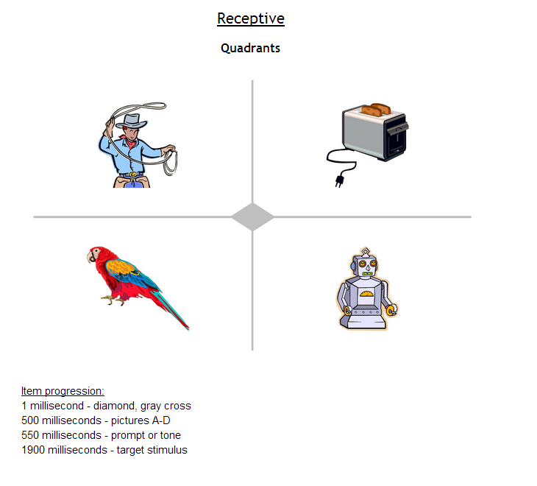
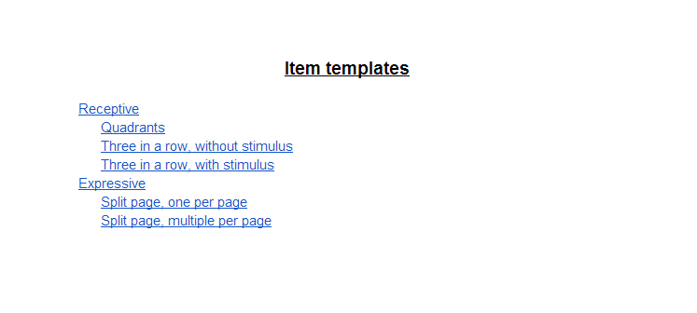

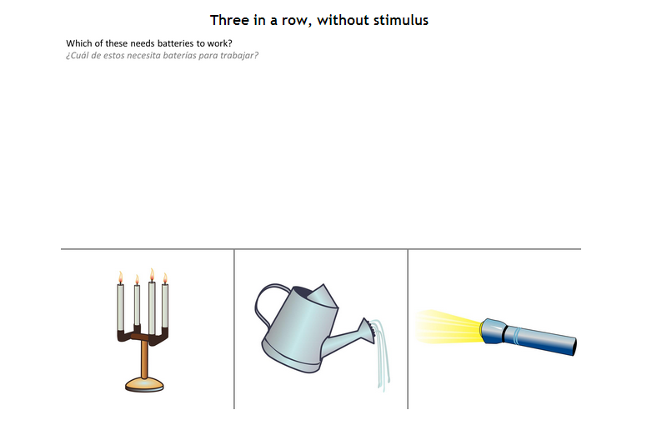

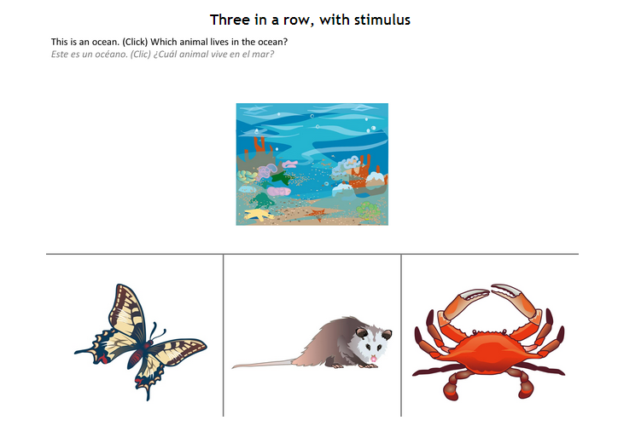
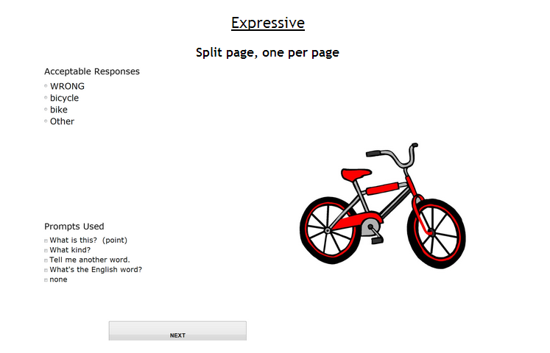

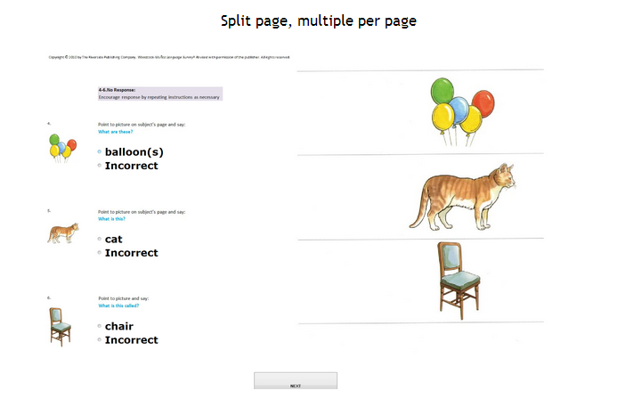

APPENDIX ONE

PROPOSAL REQUIREMENTS

TABLE OF CONTENTS

SECTION 1: GENERAL INFORMATION 1

SECTION 2: EXECUTION OF OFFER 5

SECTION 3: PROPOSER'S GENERAL QUESTIONNAIRE 8

SECTION 4: ADDENDA CHECKLIST 9

SECTION 1

GENERAL INFORMATION

1.1 Purpose

University is soliciting competitive sealed proposals from Proposers having suitable qualifications and experience providing services in accordance with the terms, conditions and requirements set forth in this RFP. This RFP provides sufficient information for interested parties to prepare and submit proposals for consideration by University.

By submitting a proposal, Proposer certifies that it understands this RFP and has full knowledge of the scope, nature, quality, and quantity of the services to be performed, the detailed requirements of the services to be provided, and the conditions under which such services are to be performed. Proposer also certifies that it understands that all costs relating to preparing a response to this RFP will be the sole responsibility of the Proposer.

PROPOSER IS CAUTIONED TO READ THE INFORMATION CONTAINED IN THIS RFP CAREFULLY AND TO SUBMIT A COMPLETE RESPONSE TO ALL REQUIREMENTS AND QUESTIONS AS DIRECTED.

1.2 Inquiries and Interpretations

University may in its sole discretion respond in writing to written inquiries concerning this RFP and mail its response as an Addendum to all parties recorded by University as having received a copy of this RFP. Only University’s responses that are made by formal written Addenda will be binding on University. Any verbal responses, written interpretations or clarifications other than Addenda to this RFP will be without legal effect. All Addenda issued by University prior to the Submittal Deadline will be and are hereby incorporated as a part of this RFP for all purposes.

Proposers are required to acknowledge receipt of each Addendum as specified in this Section. The Proposer must acknowledge all Addenda by completing, signing and returning the Addenda Checklist (ref. Section 4 of APPENDIX ONE). The Addenda Checklist must be received by University prior to the Submittal Deadline and should accompany the Proposer’s proposal.

Any interested party that receives this RFP by means other than directly from University is responsible for notifying University that it has received an RFP package, and should provide its name, address, telephone number and FAX number to University, so that if University issues Addenda to this RFP or provides written answers to questions, that information can be provided to such party.

1.3 Public Information

Proposer is hereby notified that University strictly adheres to all statutes, court decisions and the opinions of the Texas Attorney General with respect to disclosure of public information.

University may seek to protect from disclosure all information submitted in response to this RFP until such time as a final agreement is executed.

Upon execution of a final agreement, University will consider all information, documentation, and other materials requested to be submitted in response to this RFP, to be of a non-confidential and non-proprietary nature and, therefore, subject to public disclosure under the Texas Public Information Act (Government Code, Chapter 552.001, et seq.). Proposer will be advised of a request for public information that implicates their materials and will have the opportunity to raise any objections to disclosure to the Texas Attorney General. Certain information may be protected from release under Sections 552.101, 552.110, 552.113, and 552.131, Government Code.

1.4 Type of Agreement

Contractor, if any, will be required to enter into a contract with University in a form substantially similar to the Agreement between University and Contractor (the “Agreement”) attached to this RFP as APPENDIX TWO and incorporated for all purposes.

1.5 Proposal Evaluation Process

University will select Contractor by using the competitive sealed proposal process described in this Section. University will open the HSP Envelope submitted by a Proposer prior to opening the Proposer’s proposal in order to ensure that the Proposer has submitted the number of completed and signed originals of the Proposer’s HUB Subcontracting Plan (also called the HSP) that are required by this RFP (ref. Section 2.5.4 of the RFP.) All proposals submitted by the Submittal Deadline accompanied by the number of completed and signed originals of the HSP that are required by this RFP will be opened publicly to identify the name of each Proposer submitting a proposal. Any proposals that are not submitted by the Submittal Date or that are not accompanied by the number of completed and signed originals of the HSP that are required by this RFP will be rejected by University as non-responsive due to material failure to comply with advertised specifications. After the opening of the proposals and upon completion of the initial review and evaluation of the proposals, University may invite one or more selected Proposers to participate in oral presentations. University will use commercially reasonable efforts to avoid public disclosure of the contents of a proposal prior to selection of Contractor.

University may make the selection of Contractor on the basis of the proposals initially submitted, without discussion, clarification or modification. In the alternative, University may make the selection of Contractor on the basis of negotiation with any of the Proposers. In conducting such negotiations, University will use commercially reasonable efforts to avoid disclosing the contents of competing proposals.

At University's sole option and discretion, University may discuss and negotiate all elements of the proposals submitted by selected Proposers within a specified competitive range. For purposes of negotiation, University may establish, after an initial review of the proposals, a competitive range of acceptable or potentially acceptable proposals composed of the highest rated proposal(s). In that event, University will defer further action on proposals not included within the competitive range pending the selection of Contractor; provided, however, University reserves the right to include additional proposals in the competitive range if deemed to be in the best interests of University.

After submission of a proposal but before final selection of Contractor is made, University may permit a Proposer to revise its proposal in order to obtain the Proposer's best and final offer. In that event, representations made by Proposer in its revised proposal, including price and fee quotes, will be binding on Proposer. University will provide each Proposer within the competitive range with an equal opportunity for discussion and revision of its proposal. University is not obligated to select the Proposer offering the most attractive economic terms if that Proposer is not the most advantageous to University overall, as determined by University.

University reserves the right to (a) enter into an agreement for all or any portion of the requirements and specifications set forth in this RFP with one or more Proposers, (b) reject any and all proposals and re-solicit proposals, or (c) reject any and all proposals and temporarily or permanently abandon this selection process, if deemed to be in the best interests of University. Proposer is hereby notified that University will maintain in its files concerning this RFP a written record of the basis upon which a selection, if any, is made by University.

1.6 Proposer's Acceptance of Evaluation Methodology

By submitting a proposal, Proposer acknowledges (1) Proposer's acceptance of [a] the Proposal Evaluation Process (ref. Section 1.5 of APPENDIX ONE), [b] the Criteria for Selection (ref. 2.3 of this RFP), [c] the Specifications and Additional Questions (ref. Section 5 of this RFP), [d] the terms and conditions of the Agreement (ref. APPENDIX TWO), and [e] all other requirements and specifications set forth in this RFP; and (2) Proposer's recognition that some subjective judgments must be made by University during this RFP process.

1.7 Solicitation for Proposal and Proposal Preparation Costs

Proposer understands and agrees that (1) this RFP is a solicitation for proposals and University has made no representation written or oral that one or more agreements with University will be awarded under this RFP; (2) University issues this RFP predicated on University’s anticipated requirements for the Services, and University has made no representation, written or oral, that any particular scope of services will actually be required by University; and (3) Proposer will bear, as its sole risk and responsibility, any cost that arises from Proposer’s preparation of a proposal in response to this RFP.

1.8 Proposal Requirements and General Instructions

1.8.1 Proposer should carefully read the information contained herein and submit a complete proposal in response to all requirements and questions as directed.

1.8.2 Proposals and any other information submitted by Proposer in response to this RFP will become the property of University.

1.8.3 University will not provide compensation to Proposer for any expenses incurred by the Proposer for proposal preparation or for demonstrations or oral presentations that may be made by Proposer. Proposer submits its proposal at its own risk and expense.

1.8.4 Proposals that (i) are qualified with conditional clauses; (ii) alter, modify, or revise this RFP in any way; or (iii) contain irregularities of any kind, are subject to disqualification by University, at University’s sole discretion.

1.8.5 Proposals should be prepared simply and economically, providing a straightforward, concise description of Proposer's ability to meet the requirements and specifications of this RFP. Emphasis should be on completeness, clarity of content, and responsiveness to the requirements and specifications of this RFP.

1.8.6 University makes no warranty or guarantee that an award will be made as a result of this RFP. University reserves the right to accept or reject any or all proposals, waive any formalities, procedural requirements, or minor technical inconsistencies, and delete any requirement or specification from this RFP or the Agreement when deemed to be in University's best interest. University reserves the right to seek clarification from any Proposer concerning any item contained in its proposal prior to final selection. Such clarification may be provided by telephone conference or personal meeting with or writing to University, at University’s sole discretion. Representations made by Proposer within its proposal will be binding on Proposer.

1.8.7 Any proposal that fails to comply with the requirements contained in this RFP may be rejected by University, in University’s sole discretion.

1.9 Preparation and Submittal Instructions

1.9.1 Specifications and Additional Questions

Proposals must include responses to the questions in Specifications and Additional Questions (ref. Section 5 of this RFP). Proposer should reference the item number and repeat the question in its response. In cases where a question does not apply or if unable to respond, Proposer should refer to the item number, repeat the question, and indicate N/A (Not Applicable) or N/R (No Response), as appropriate. Proposer should explain the reason when responding N/A or N/R.

1.9.2 Execution of Offer

Proposer must complete, sign and return the attached Execution of Offer (ref. Section 2 of APPENDIX ONE) as part of its proposal. The Execution of Offer must be signed by a representative of Proposer duly authorized to bind the Proposer to its proposal. Any proposal received without a completed and signed Execution of Offer may be rejected by University, in its sole discretion.

1.9.3 Pricing and Delivery Schedule

Proposer must complete and return the Pricing and Delivery Schedule (ref. Section 6 of this RFP), as part of its proposal. In the Pricing and Delivery Schedule, the Proposer should describe in detail (a) the total fees for the entire scope of the Services; and (b) the method by which the fees are calculated. The fees must be inclusive of all associated costs for delivery, labor, insurance, taxes, overhead, and profit.

University will not recognize or accept any charges or fees to perform the Services that are not specifically stated in the Pricing and Delivery Schedule.

In the Pricing and Delivery Schedule, Proposer should describe each significant phase in the process of providing the Services to University, and the time period within which Proposer proposes to be able to complete each such phase.

1.9.4 Proposer’s General Questionnaire

Proposals must include responses to the questions in Proposer’s General Questionnaire (ref. Section 3 of APPENDIX ONE). Proposer should reference the item number and repeat the question in its response. In cases where a question does not apply or if unable to respond, Proposer should refer to the item number, repeat the question, and indicate N/A (Not Applicable) or N/R (No Response), as appropriate. Proposer should explain the reason when responding N/A or N/R.

1.9.5 Addenda Checklist

Proposer should acknowledge all Addenda to this RFP (if any) by completing, signing and returning the Addenda Checklist (ref. Section 4 of APPENDIX ONE) as part of its proposal. Any proposal received without a completed and signed Addenda Checklist may be rejected by University, in its sole discretion.

1.9.6 Submission

Proposer should submit all proposal materials enclosed in a sealed envelope, box, or container. The RFP No. (ref. Section 1.3 of this RFP) and the Submittal Deadline (ref. Section 2.1 of this RFP) should be clearly shown in the lower left-hand corner on the top surface of the container. In addition, the name and the return address of the Proposer should be clearly visible.

Proposer must also submit the number of originals of the HUB Subcontracting Plan (also called the HSP) as required by this RFP (ref. Section 2.5 of the RFP.)

Upon Proposer’s request and at Proposer’s expense, University will return to a Proposer its proposal received after the Submittal Deadline if the proposal is properly identified. University will not under any circumstances consider a proposal that is received after the Submittal Deadline or which is not accompanied by the number of completed and signed originals of the HSP that are required by this RFP.

University will not accept proposals submitted by telephone, proposals submitted by Facsimile (“FAX”) transmission, or proposals submitted by electronic transmission (i.e., e-mail) in response to this RFP.

Except as otherwise provided in this RFP, no proposal may be changed, amended, or modified after it has been submitted to University. However, a proposal may be withdrawn and resubmitted at any time prior to the Submittal Deadline. No proposal may be withdrawn after the Submittal Deadline without University’s consent, which will be based on Proposer's submittal of a written explanation and documentation evidencing a reason acceptable to University, in University’s sole discretion.

By signing the Execution of Offer (ref. Section 2 of APPENDIX ONE) and submitting a proposal, Proposer certifies that any terms, conditions, or documents attached to or referenced in its proposal are applicable to this procurement only to the extent that they (a) do not conflict with the laws of the State of Texas or this RFP and (b) do not place any requirements on University that are not set forth in this RFP or in the Appendices to this RFP. Proposer further certifies that the submission of a proposal is Proposer's good faith intent to enter into the Agreement with University as specified herein and that such intent is not contingent upon University's acceptance or execution of any terms, conditions, or other documents attached to or referenced in Proposer’s proposal.

1.9.7 Page Size, Binders, and Dividers

Proposals must be typed on letter-size (8-1/2” x 11”) paper, and must be submitted in a binder. Preprinted material should be referenced in the proposal and included as labeled attachments. Sections within a proposal should be divided by tabs for ease of reference.

1.9.8 Table of Contents

Proposals must include a Table of Contents with page number references. The Table of Contents must contain sufficient detail and be organized according to the same format as presented in this RFP, to allow easy reference to the sections of the proposal as well as to any separate attachments (which should be identified in the main Table of Contents). If a Proposer includes supplemental information or non-required attachments with its proposal, this material should be clearly identified in the Table of Contents and organized as a separate section of the proposal.

1.9.9 Pagination

All pages of the proposal should be numbered sequentially in Arabic numerals (1, 2, 3, etc.). Attachments should be numbered or referenced separately.

SECTION 2

Execution of Offer

THIS EXECUTION OF OFFER MUST BE COMPLETED, SIGNED AND RETURNED WITH PROPOSER'S PROPOSAL. FAILURE TO COMPLETE, SIGN AND RETURN THIS EXECUTION OF OFFER WITH THE PROPOSER’S PROPOSAL MAY RESULT IN THE REJECTION OF THE PROPOSAL.

2.1 By signature hereon, Proposer represents and warrants the following:

2.1.1 Proposer acknowledges and agrees that (1) this RFP is a solicitation for a proposal and is not a contract or an offer to contract; (2) the submission of a proposal by Proposer in response to this RFP will not create a contract between University and Proposer; (3) University has made no representation or warranty, written or oral, that one or more contracts with University will be awarded under this RFP; and (4) Proposer will bear, as its sole risk and responsibility, any cost arising from Proposer’s preparation of a response to this RFP.

2.1.2 Proposer is a reputable company that is lawfully and regularly engaged in providing the Services.

2.1.3 Proposer has the necessary experience, knowledge, abilities, skills, and resources to perform the Services.

2.1.4 Proposer is aware of, is fully informed about, and is in full compliance with all applicable federal, state and local laws, rules, regulations and ordinances.

2.1.5 Proposer understands (i) the requirements and specifications set forth in this RFP and (ii) the terms and conditions set forth in the Agreement under which Proposer will be required to operate.

2.1.6 If selected by University, Proposer will not delegate any of its duties or responsibilities under this RFP or the Agreement to any sub-contractor, except as expressly provided in the Agreement.

2.1.7 If selected by University, Proposer will maintain any insurance coverage as required by the Agreement during the term thereof.

2.1.8 All statements, information and representations prepared and submitted in response to this RFP are current, complete, true and accurate. Proposer acknowledges that University will rely on such statements, information and representations in selecting Contractor. If selected by University, Proposer will notify University immediately of any material change in any matters with regard to which Proposer has made a statement or representation or provided information.

2.1.9 Proposer will defend with counsel approved by University, indemnify, and hold harmless University, The University of Texas System, the State of Texas, and all of their regents, officers, agents and employees, from and against all actions, suits, demands, costs, damages, liabilities and other claims of any nature, kind or description, including reasonable attorneys’ fees incurred in investigating, defending or settling any of the foregoing, arising out of, connected with, or resulting from any negligent acts or omissions or willful misconduct of Proposer or any agent, employee, subcontractor, or supplier of Proposer in the execution or performance of any contract or agreement resulting from this RFP.

2.1.10 Pursuant to Sections 2107.008 and 2252.903, Government Code, any payments owing to Proposer under any contract or agreement resulting from this RFP may be applied directly to any debt or delinquency that Proposer owes the State of Texas or any agency of the State of Texas regardless of when it arises, until such debt or delinquency is paid in full.

2.2 By signature hereon, Proposer offers and agrees to furnish the Services to University and comply with all terms, conditions, requirements and specifications set forth in this RFP.

2.3 By signature hereon, Proposer affirms that it has not given or offered to give, nor does Proposer intend to give at any time hereafter, any economic opportunity, future employment, gift, loan, gratuity, special discount, trip, favor or service to a public servant in connection with its submitted proposal. Failure to sign this Execution of Offer, or signing with a false statement, may void the submitted proposal or any resulting contracts, and the Proposer may be removed from all proposal lists at University.

2.4 By signature hereon, Proposer certifies that it is not currently delinquent in the payment of any taxes due under Chapter 171, Tax Code, or that Proposer is exempt from the payment of those taxes, or that Proposer is an out-of-state taxable entity that is not subject to those taxes, whichever is applicable. A false certification will be deemed a material breach of any resulting contract or agreement and, at University's option, may result in termination of any resulting contract or agreement.

2.5 By signature hereon, Proposer hereby certifies that neither Proposer nor any firm, corporation, partnership or institution represented by Proposer, or anyone acting for such firm, corporation or institution, has violated the antitrust laws of the State of Texas, codified in Section 15.01, et seq., Business and Commerce Code, or the Federal antitrust laws, nor communicated directly or indirectly the proposal made to any competitor or any other person engaged in such line of business.

2.6 By signature hereon, Proposer certifies that the individual signing this document and the documents made a part of this RFP, is authorized to sign such documents on behalf of Proposer and to bind Proposer under any agreements and other contractual arrangements that may result from the submission of Proposer’s proposal.

2.7 By signature hereon, Proposer certifies as follows:

"Under Section 231.006, Family Code, relating to child support, Proposer certifies that the individual or business entity named in the Proposer’s proposal is not ineligible to receive the specified contract award and acknowledges that any agreements or other contractual arrangements resulting from this RFP may be terminated if this certification is inaccurate."

2.8 By signature hereon, Proposer certifies that (i) no relationship, whether by blood, marriage, business association, capital funding agreement or by any other such kinship or connection exists between the owner of any Proposer that is a sole proprietorship, the officers or directors of any Proposer that is a corporation, the partners of any Proposer that is a partnership, the joint venturers of any Proposer that is a joint venture or the members or managers of any Proposer that is a limited liability company, on one hand, and an employee of any component of The University of Texas System, on the other hand, other than the relationships which have been previously disclosed to University in writing; (ii) Proposer has not been an employee of any component institution of The University of Texas System within the immediate twelve (12) months prior to the Submittal Deadline; and (iii) no person who, in the past four (4) years served as an executive of a state agency was involved with or has any interest in Proposer’s proposal or any contract resulting from this RFP (ref. Section 669.003, Government Code). All disclosures by Proposer in connection with this certification will be subject to administrative review and approval before University enters into a contract or agreement with Proposer.

2.9 By signature hereon, Proposer certifies its compliance with all federal laws and regulations pertaining to Equal Employment Opportunities and Affirmative Action.

2.10 By signature hereon, Proposer represents and warrants that all products and services offered to University in response to this RFP meet or exceed the safety standards established and promulgated under the Federal Occupational Safety and Health Law (Public Law 91-596) and the Texas Hazard Communication Act, Chapter 502, Health and Safety Code, and all related regulations in effect or proposed as of the date of this RFP.

2.11 Proposer will and has disclosed, as part of its proposal, any exceptions to the certifications stated in this Execution of Offer. All such disclosures will be subject to administrative review and approval prior to the time University makes an award or enters into any contract or agreement with Proposer.

2.12 If Proposer will sell or lease computer equipment to the University under any agreements or other contractual arrangements that may result from the submission of Proposer’s proposal then, pursuant to Section 361.965(c), Health & Safety Code, Proposer certifies that it is in compliance with the Manufacturer Responsibility and Consumer Convenience Computer Equipment Collection and Recovery Act set forth in Chapter 361, Subchapter Y, Health & Safety Code and the rules adopted by the Texas Commission on Environmental Quality under that Act as set forth in Title 30, Chapter 328, Subchapter I, Texas Administrative Code. Section 361.952(2), Health & Safety Code, states that, for purposes of the Manufacturer Responsibility and Consumer Convenience Computer Equipment Collection and Recovery Act, the term “computer equipment” means a desktop or notebook computer and includes a computer monitor or other display device that does not contain a tuner.

2.13 Proposer should complete the following information:

If Proposer is a Corporation, then State of Incorporation:

If Proposer is a Corporation then Proposer’s Corporate Charter Number: ______

RFP No.: R1429

NOTICE: With few exceptions, individuals are entitled on request to be informed about the information that governmental bodies of the State of Texas collect about such individuals. Under Sections 552.021 and 552.023, Government Code, individuals are entitled to receive and review such information. Under Section 559.004, Government Code, individuals are entitled to have governmental bodies of the State of Texas correct information about such individuals that is incorrect.

Submitted and Certified By:

(Proposer Institution’s Name)

(Signature of Duly Authorized Representative)

(Printed Name/Title)

(Date Signed)

(Proposer’s Street Address)

(City, State, Zip Code)

(Telephone Number)

(FAX Number)

________________________________________________________________________
(Email Address)

________________________________________________________________________
(Tax ID Number)

SECTION 3

PROPOSER’S GENERAL QUESTIONNAIRE

NOTICE: With few exceptions, individuals are entitled on request to be informed about the information that governmental bodies of the State of Texas collect about such individuals. Under Sections 552.021 and 552.023, Government Code, individuals are entitled to receive and review such information. Under Section 559.004, Government Code, individuals are entitled to have governmental bodies of the State of Texas correct information about such individuals that is incorrect.

Proposals must include responses to the questions contained in this Proposer’s General Questionnaire. Proposer should reference the item number and repeat the question in its response. In cases where a question does not apply or if unable to respond, Proposer should refer to the item number, repeat the question, and indicate N/A (Not Applicable) or N/R (No Response), as appropriate. Proposer will explain the reason when responding N/A or N/R.

3.1 Proposer Profile

3.1.1 Legal name of Proposer’s company:

Address of principal place of business:

Address of office that would be providing service under the Agreement:

Number of years in Business:

State of incorporation:

Number of Employees:

Annual Revenues Volume:

Name of Parent Corporation, if any ______________________________

NOTE: If Proposer is a subsidiary, University prefers to enter into a contract or agreement with the Parent Corporation or to receive assurances of performance from the Parent Corporation.

3.1.2 State whether Proposer will provide a copy of its financial statements for the past two (2) years, if requested by University.

3.1.3 Proposer will provide a financial rating of the Proposer entity and any related documentation (such as a Dunn and Bradstreet analysis) that indicates the financial stability of Proposer.

3.1.4 Is Proposer currently for sale or involved in any transaction to expand or to become acquired by another business entity? If yes, Proposer will explain the expected impact, both in organizational and directional terms.

3.1.5 Proposer will provide any details of all past or pending litigation or claims filed against Proposer that would affect its performance under the Agreement with University (if any).

3.1.6 Is Proposer currently in default on any loan agreement or financing agreement with any bank, financial institution, or other entity? If yes, Proposer will specify the pertinent date(s), details, circumstances, and describe the current prospects for resolution.

3.1.7 Does any relationship exist (whether by family kinship, business association, capital funding agreement, or any other such relationship) between Proposer and any employee of University? If yes, Proposer will explain.

SECTION 4

ADDENDA CHECKLIST

Proposal of: ___________________________________
(Proposer Company Name)

To: The University of Texas Health Science Center at Houston

Ref: RFP No. 744-R1429 TX-KEA Mobile Technology

Ladies and Gentlemen:

The undersigned Proposer hereby acknowledges receipt of the following Addenda to the captioned RFP (initial if applicable).

No. 1 _____ No. 2 _____ No. 3 _____ No. 4 _____ No. 5 _____

Respectfully submitted,

Proposer: ____________________________

By: __________________________________
(Authorized Signature for Proposer)

Name: _______________________________

Title: ________________________________

Date: ________________________________

APPENDIX TWO

SAMPLE AGREEMENT

(SEPARATE ATTACHMENT)

APPENDIX THREE

HUB SUBCONTRACTING PLAN

(SEPARATE ATTACHMENT)

APPENDIX FIVE

ACCESS BY INDIVIDUALS WITH DISABILITIES

Access by Individuals with Disabilities. Contractor represents and warrants (“EIR Accessibility Warranty”) that the electronic and information resources and all associated information, documentation, and support that it provides to University under this Agreement (collectively, the “EIRs”) comply with the applicable requirements set forth in Title 1, Chapter 213, Texas Administrative Code, and Title 1, Chapter 206, Rule §206.70, Texas Administrative Code (as authorized by Chapter 2054, Subchapter M, Government Code.) To the extent Contractor becomes aware that the EIRs, or any portion thereof, do not comply with the EIR Accessibility Warranty, then Contractor represents and warrants that it will, at no cost to University, either (1) perform all necessary remediation to make the EIRs satisfy the EIR Accessibility Warranty or (2) replace the EIRs with new EIRs that satisfy the EIR Accessibility Warranty. In the event that Contractor fails or is unable to do so, then University may terminate this Agreement and Contractor will refund to University all amounts University has paid under this Agreement within thirty (30) days after the termination date.

APPENDIX SIX

ELECTRONIC AND INFORMATION RESOURCES ENVIRONMENT SPECIFICATIONS

The specifications, representations, warranties and agreements set forth in Proposer’s responses to this APPENDIX SIX will be incorporated into the Agreement.

University is primarily a Microsoft products environment.

Basic Specifications

- If the EIR will be hosted by University, please describe the overall environment requirements for the EIR (size the requirements to support the number of concurrent users, the number of licenses and the input/output generated by the application as requested in the application requirements).
- Hardware: If Proposer will provide hardware, does the hardware have multiple hard drives utilizing a redundant RAID configuration for fault tolerance? Are redundant servers included as well?
- Operating System and Version:
- Web Server: Is a web server required? If so, what web application is required (Apache or IIS)? What version? Are add-ins required?
- Application Server:
- Database:
- Other Requirements: Are any other hardware or software components required?
- Assumptions: List any assumptions made as part of the identification of these environment requirements.
- Storage: What are the space/storage requirements of this implementation?
- Users: What is the maximum number of users this configuration will support?
- Clustering: How does the EIR handle clustering over multiple servers?
- Virtual Server Environment: Can the EIR be run in a virtual server environment?

- If the EIR will be hosted by Proposer, describe in detail what the hosted solution includes, and address, specifically, the following issues:
A. Describe the audit standards of the physical security of the facility; and
B. Indicate whether Proposer is willing to allow an audit by University or its representative.

- If the user and administrative interfaces for the EIR are web-based, do the interfaces support Firefox on Mac as well as Windows and Safari on the Macintosh?

- If the EIR requires special client software, what are the environment requirements for that client software?

- Manpower Requirements: Who will operate and maintain the EIR? Will additional University full time employees (FTEs) be required? Will special training on the EIR be required by Proposer’s technical staff? What is the estimated cost of required training.

- Upgrades and Patches: Describe Proposer’s strategy regarding EIR upgrades and patches for both the server and, if applicable, the client software. Included Proposer’s typical release schedule, recommended processes, estimated outage and plans for next version/major upgrade.

Security

- Has the EIR been tested for application security vulnerabilities? For example, has the EIR been evaluated against the Open Web Application Security Project (“OWASP”) Top 10 list that includes flaws like cross site scripting and SQL injection? If so, please provide the scan results and specify the tool used. University will not take final delivery of the EIR if University determines there are serious vulnerabilities within the EIR.

- Which party, Proposer or University, will be responsible for maintaining critical EIR application security updates?

- If the EIR is hosted, indicate whether Proposer’s will permit University to conduct a penetration test on University’s instance of the EIR.

- If confidential data, including HIPAA or FERPA data, is stored in the EIR, will the data be encrypted at rest and in transmittal?

Integration

1. Is the EIR authentication Security Assertion Markup Language (“SAML”) compliant? Has Proposer ever implemented the EIR with Shibboleth authentication? If not, does the EIR integrate with Active Directory? Does the EIR support SSL connections to this directory service?

2. Does the EIR rely on Active Directory for group management and authorization or does the EIR maintain a local authorization/group database?

3. What logging capabilities does the EIR have? If this is a hosted EIR solution, will University have access to implement logging with University’s standard logging and monitoring tools, RSA’s Envision?

4. Does the EIR have an application programming interface (“API”) that enables us to incorporate it with other applications run by the University? If so, is the API .Net based? Web Services-based? Other?

- Will University have access to the EIR source code? If so, will the EIR license permit University to make modifications to the source code? Will University’s modifications be protected in future upgrades?

- Will Proposer place the EIR source code in escrow with an escrow agent so that if Proposer is no longer in business or Proposer has discontinued support, the EIR source code will be available to University.

Accessibility Information

1. Please complete the Voluntary Product Accessibility Template (“VPAT”) found at http://www.itic.org:8080/dotAsset/5644ecd2-5024-417f-bc23-a52650f47ef8.doc and submit the VPAT with Proposer’s proposal.

