CAMPUS MAP

8:30am
Operations Center Building (OCB) - Lobby Area
1851 Cross Point Ave. (free visitor parking available)
Houston, TX 77054

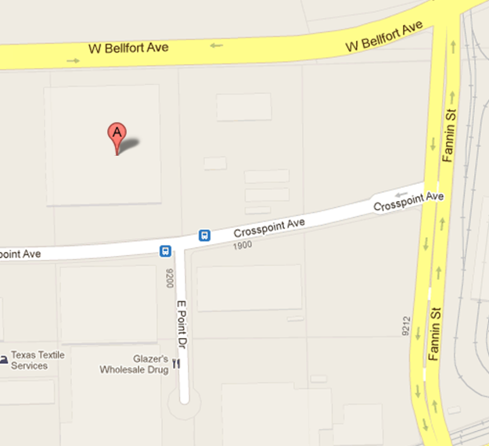
Visitor Parking Lot
OCB

9:15am
School of Nursing (SON) – Lobby Area
6901 Bertner Avenue (underground parking garage available at MDA across street)
Houston, TX 77030

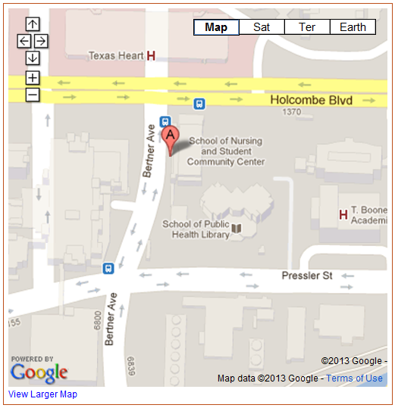
SPH
Pay Parking Garage
Pay Parking Garage
Pay Parking Garage
SON

From the School of Nursing (SON), we will proceed on to:
School of Public Health (SPH) @ 9:45am

10:30am
Cyclotron Building (CYC) – Outside facility door
6431 Fannin Street (parking garage available at UPG across street)
Houston, TX 77030
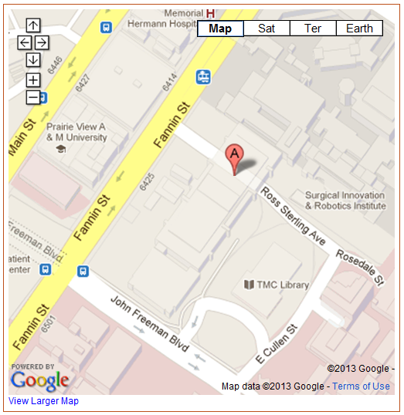
CYC

Pay Parking Garage
MSE
MSB

11:20am
Harris County Psychiatric Hospital (HCPC) - Lobby Area
2800 S. MacGregor Way (surface parking available across from HCPC)
Houston, TX 77030

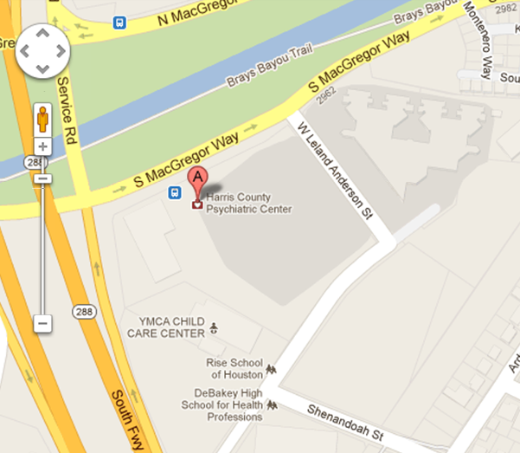
Pay Parking Lot
HCPC

